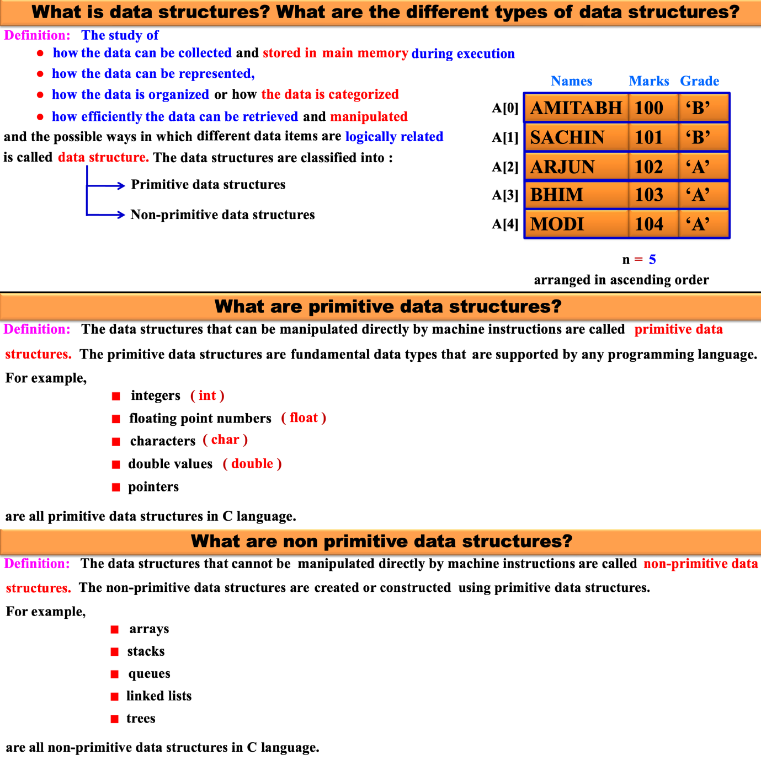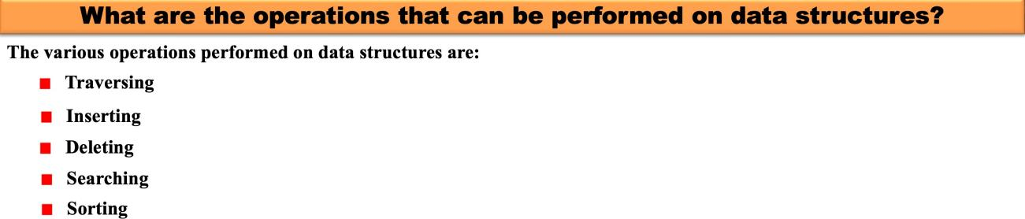
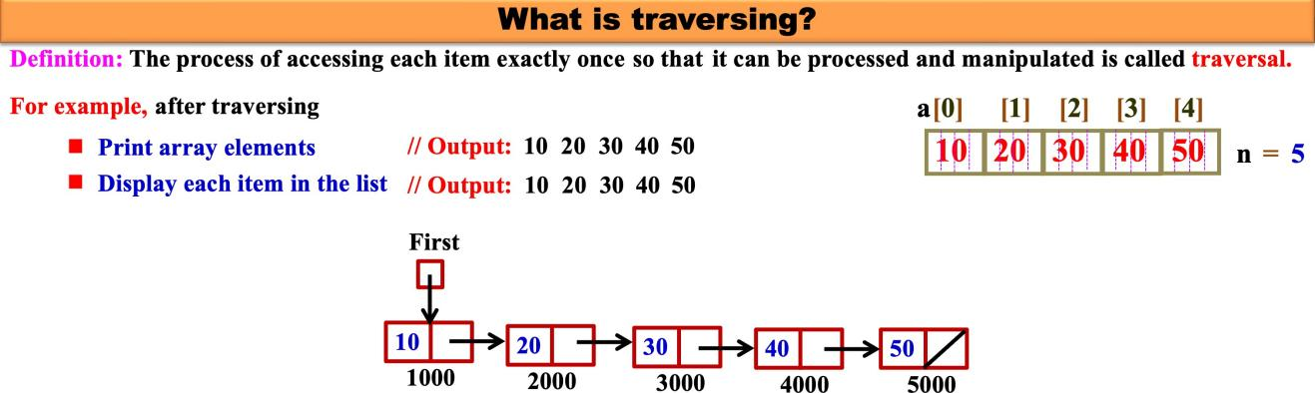

When we use structures?
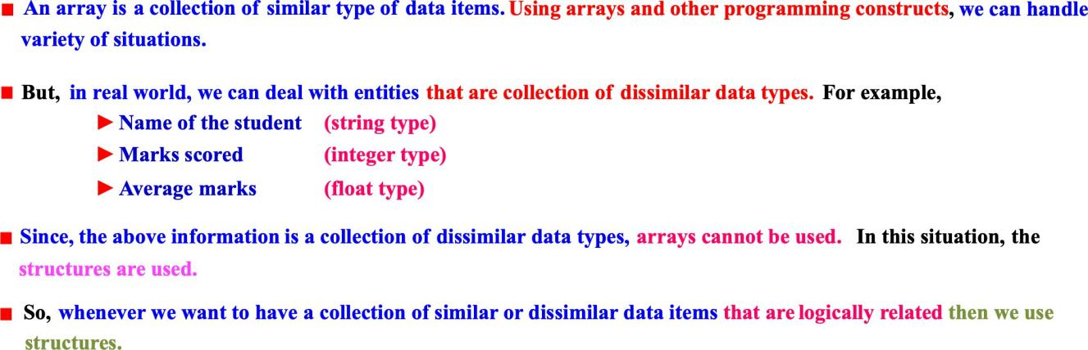
What is a structure? What is the syntax to define a structure?
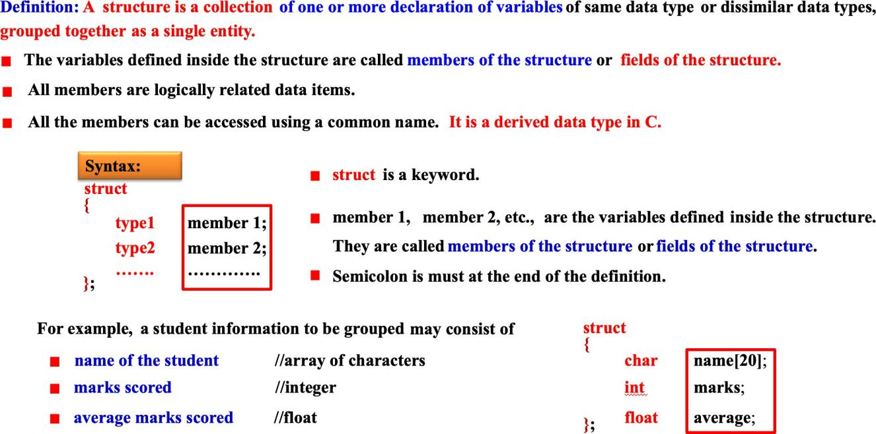
Note:
What are the different types of structures?
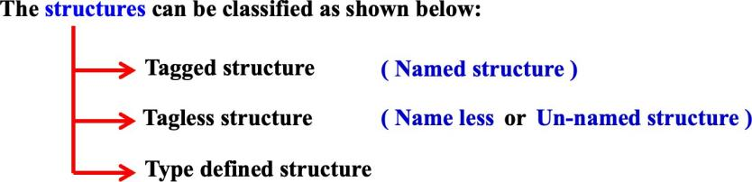
What is tagged structure? How to define tagged structure?
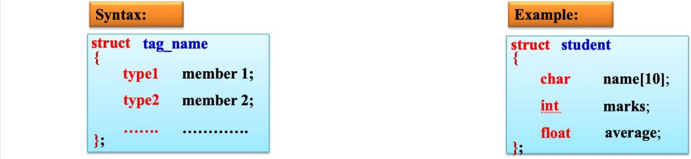

What is structure declaration? How to declare structure variables?
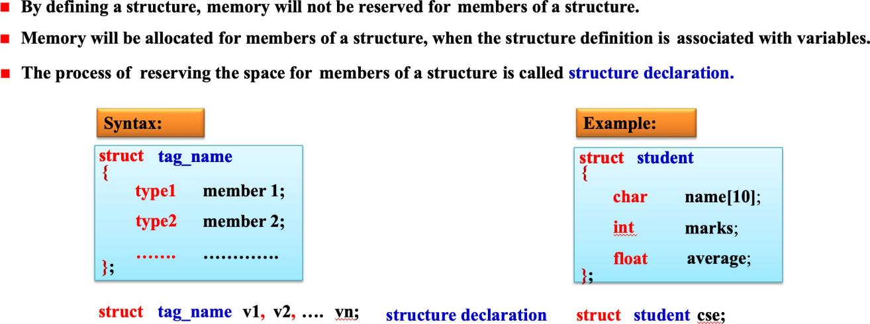
How and when memory is allocated for a structure?
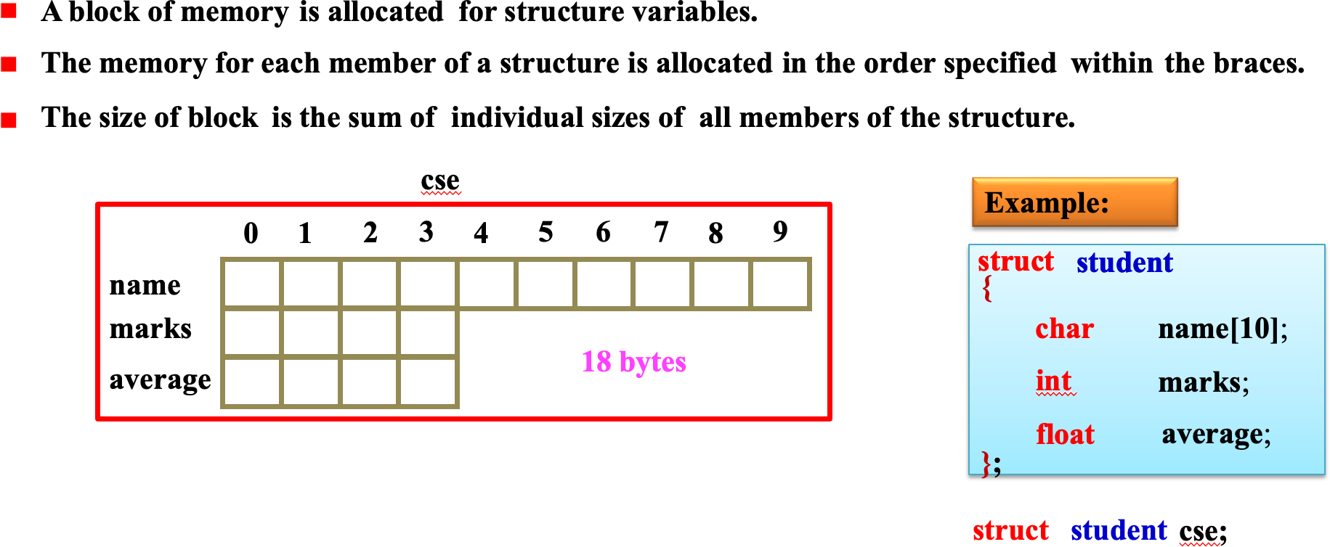
How to initialize tagged structure?
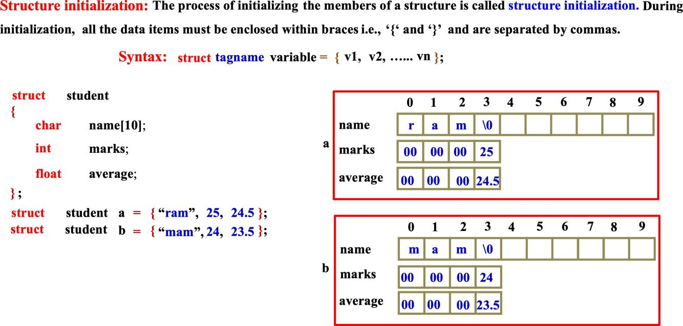

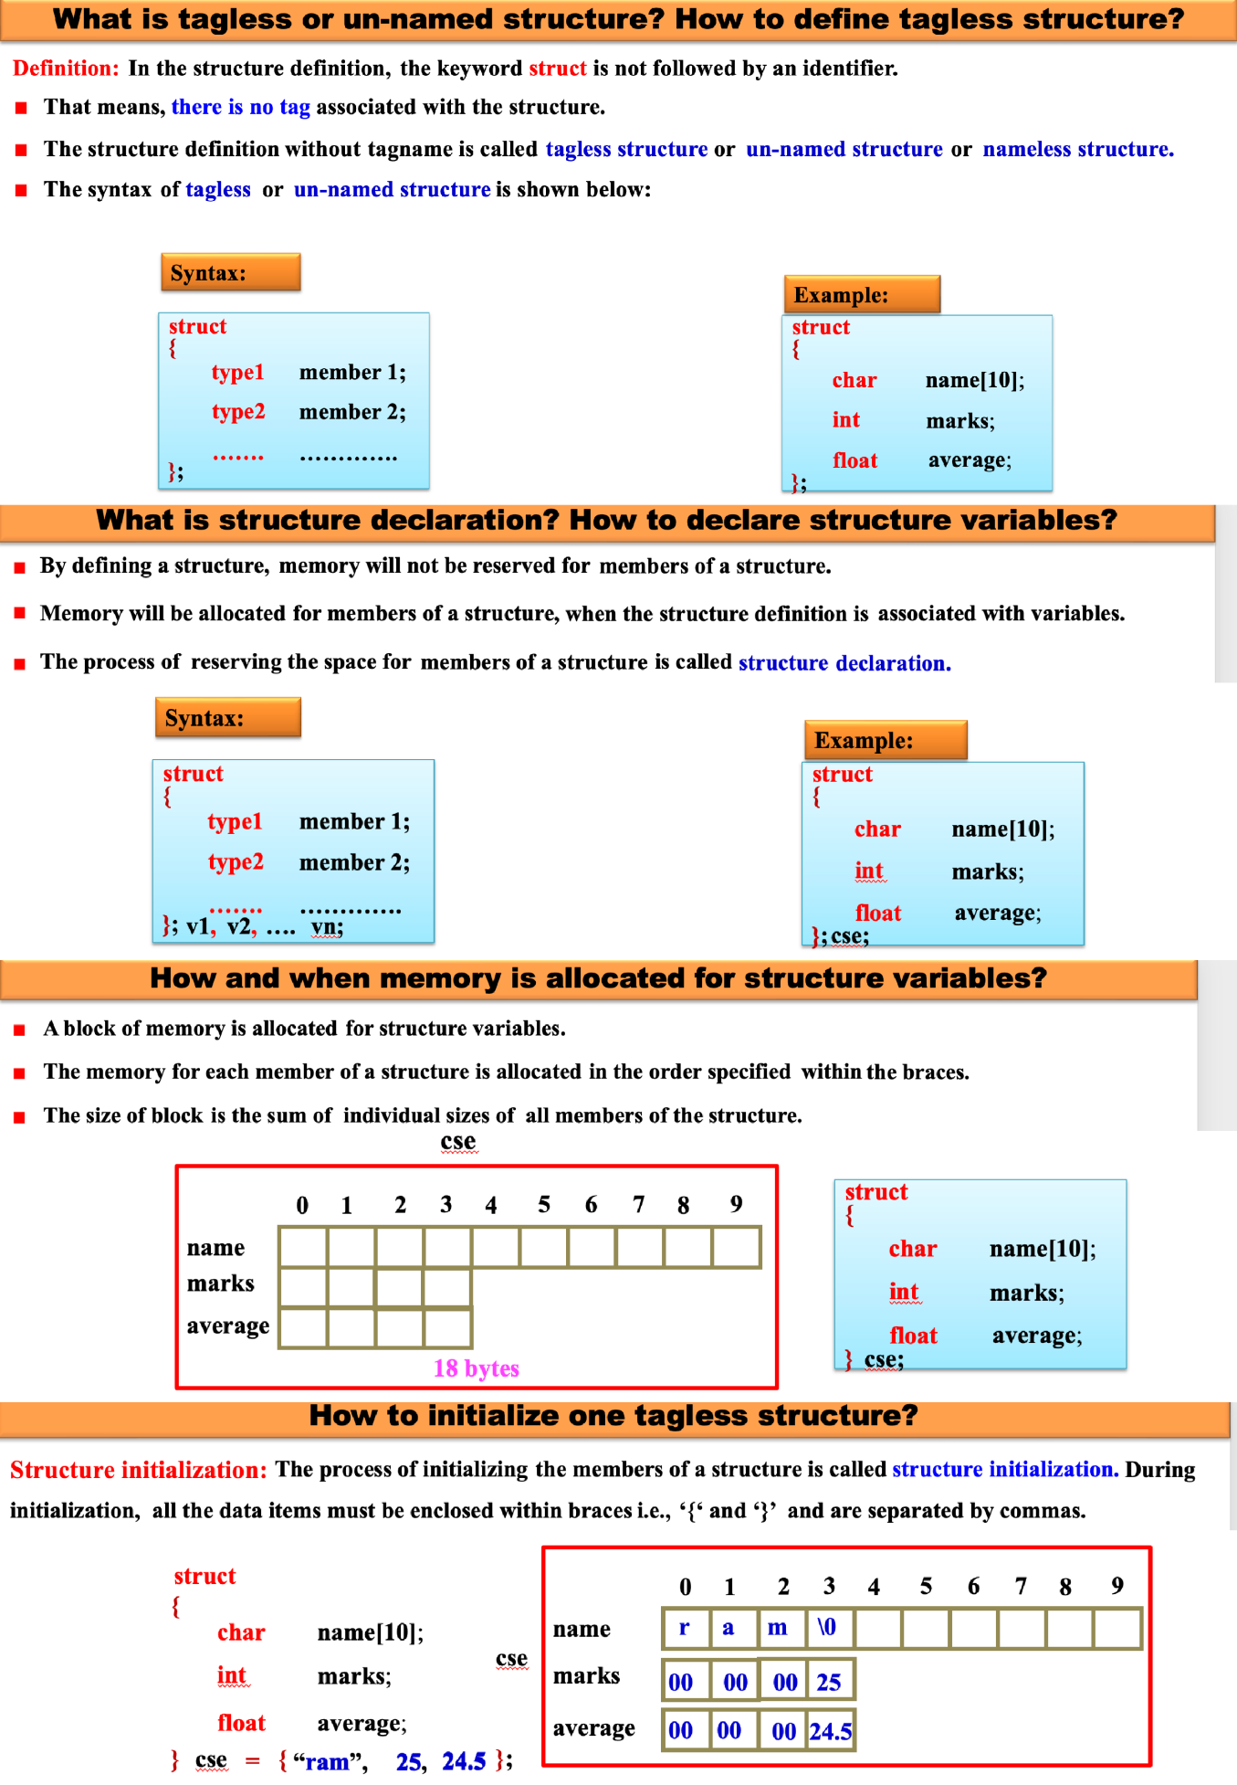

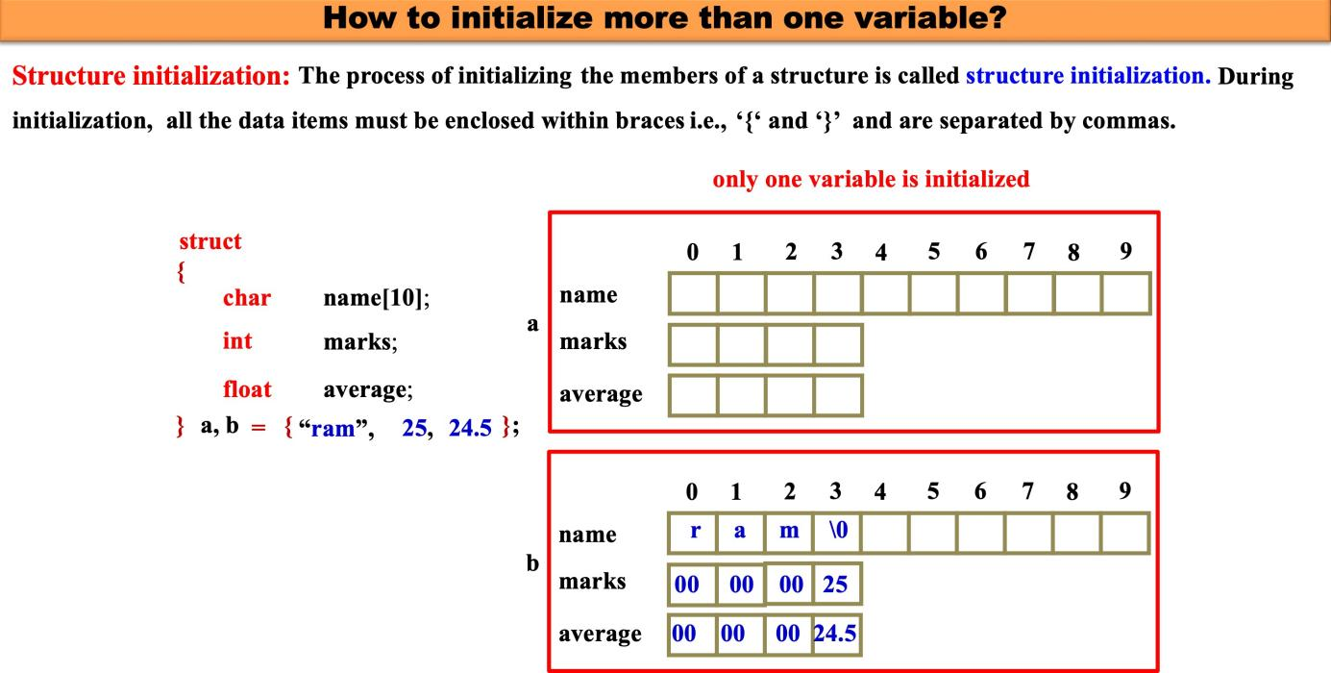
More than one variable is initialized as shown below:
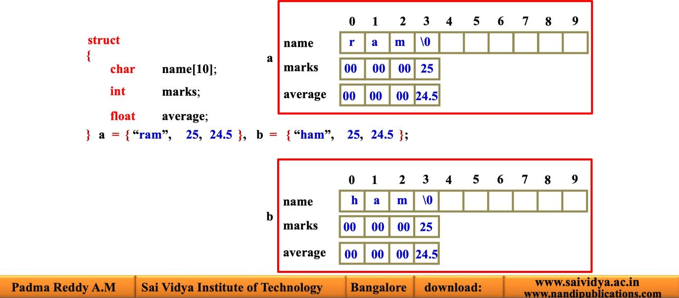

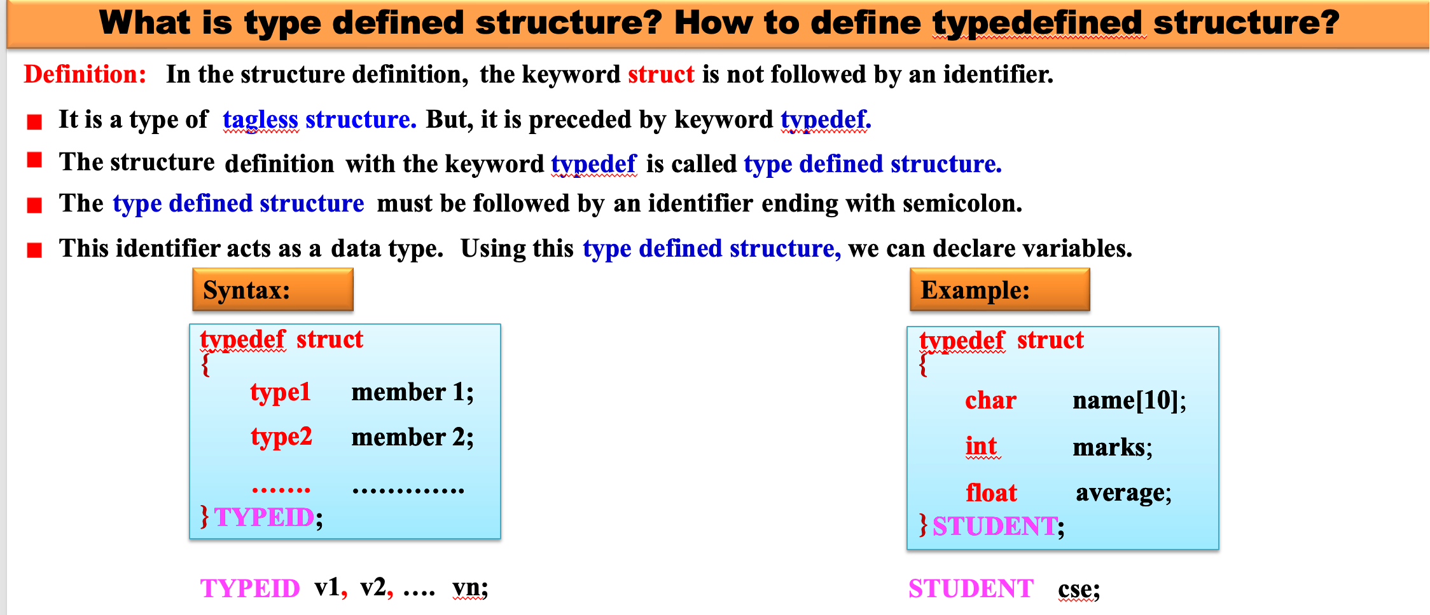
What are the different methods using which structure variables can be defined using typedef?

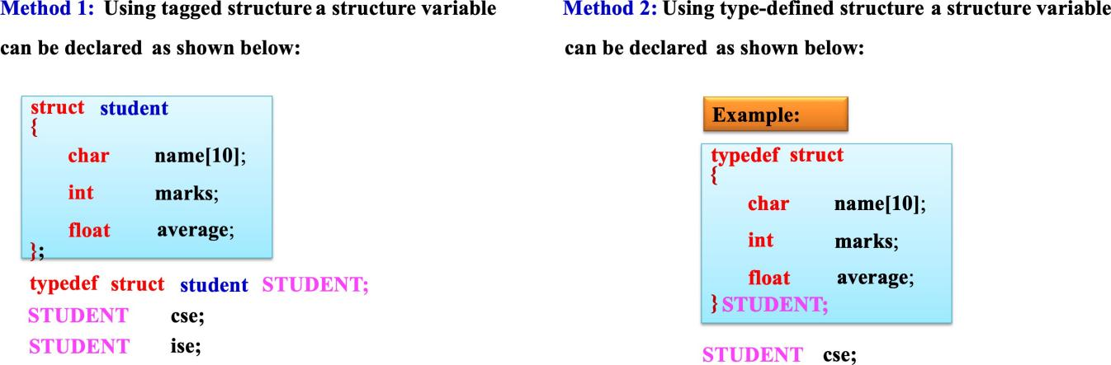
How to initialize type-defined structure?
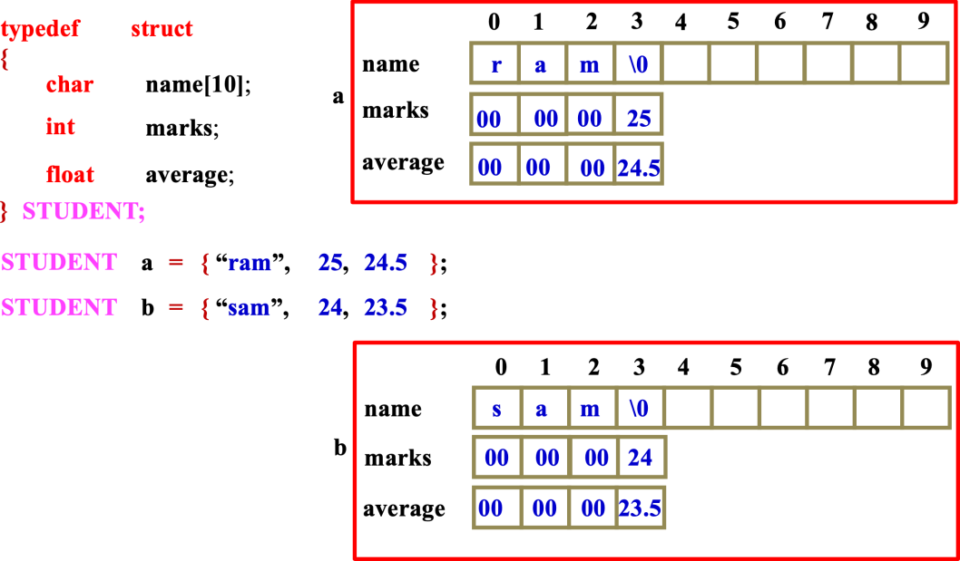
How to initialize structure variables partially?

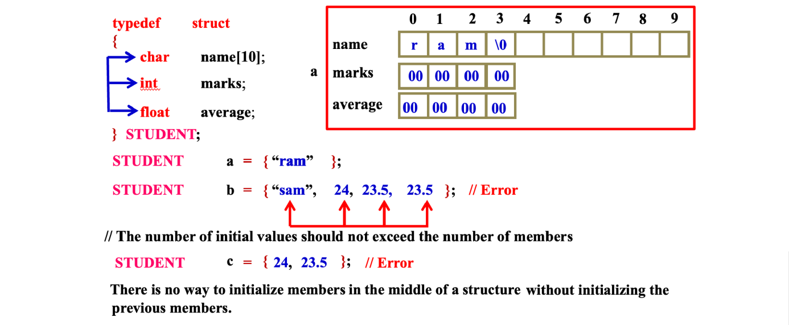
Is it possible to initialize the members without declaring the variables? Consider the following program segment:
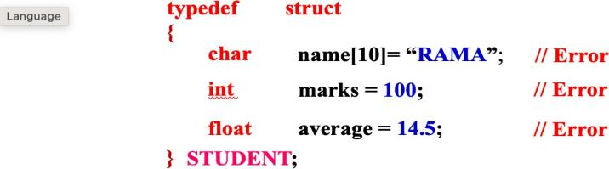

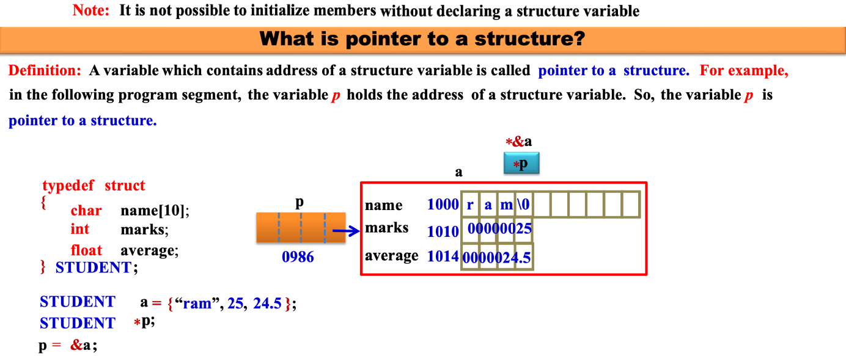
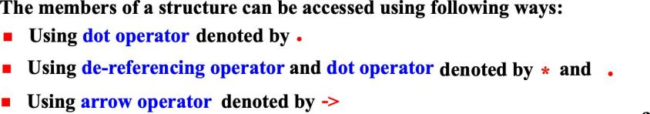

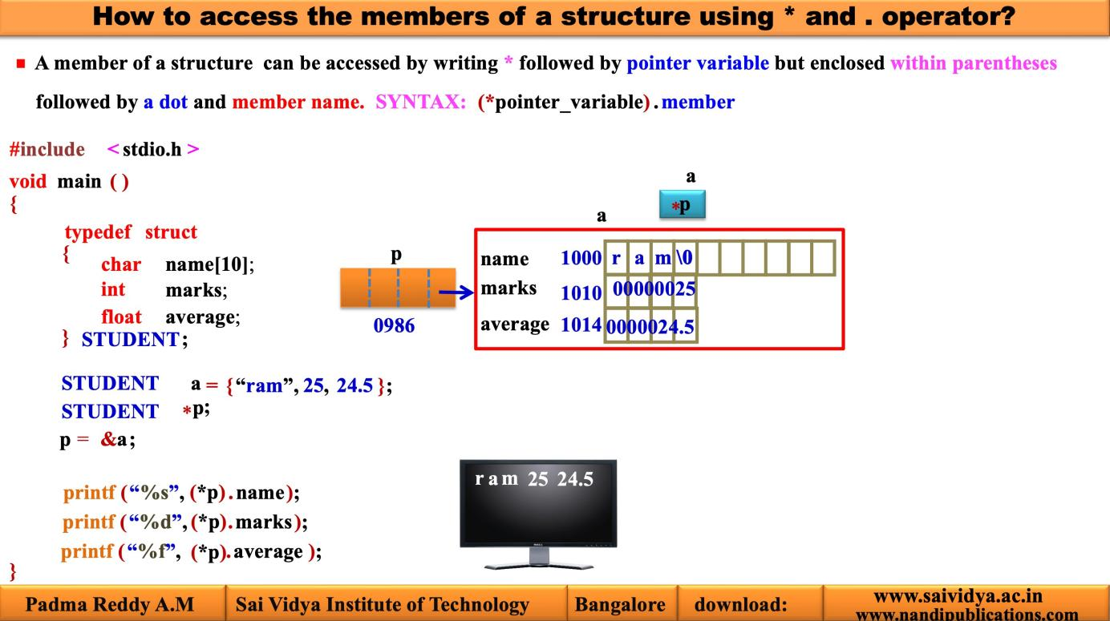
]
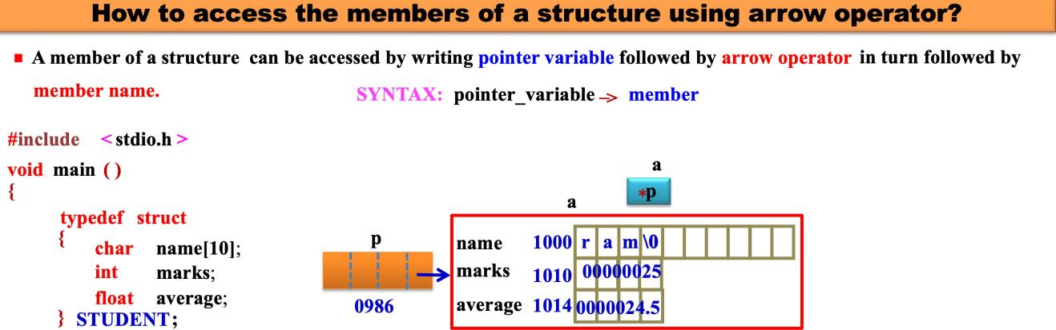

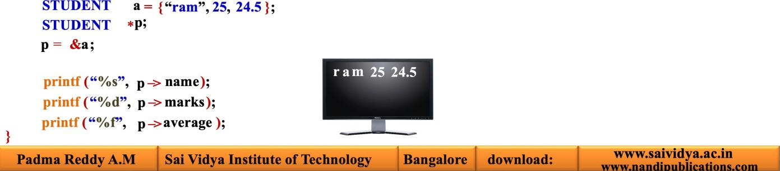

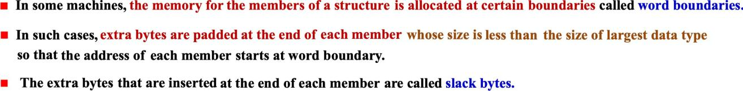

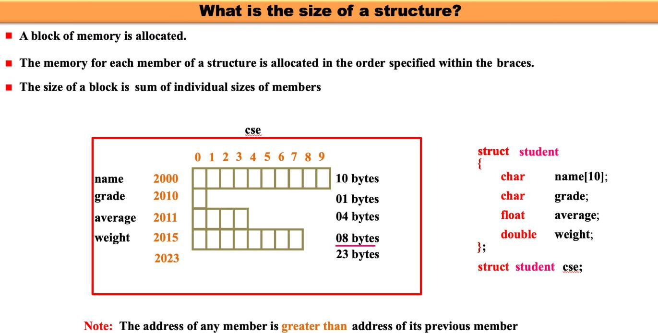
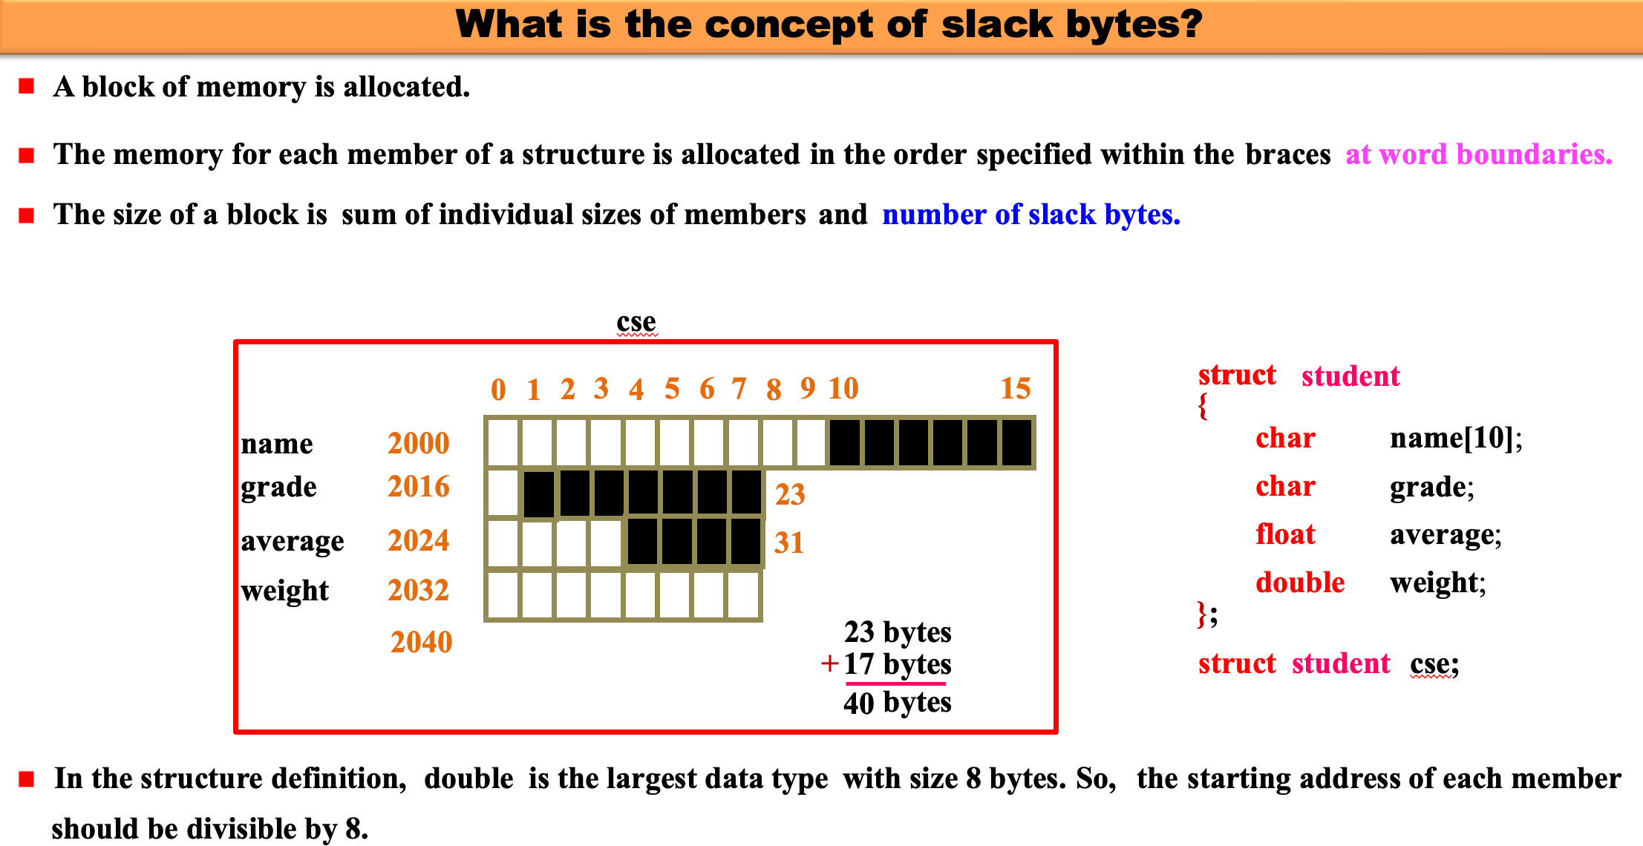
Note: The slack bytes are shown using black boxes in the above figure.’

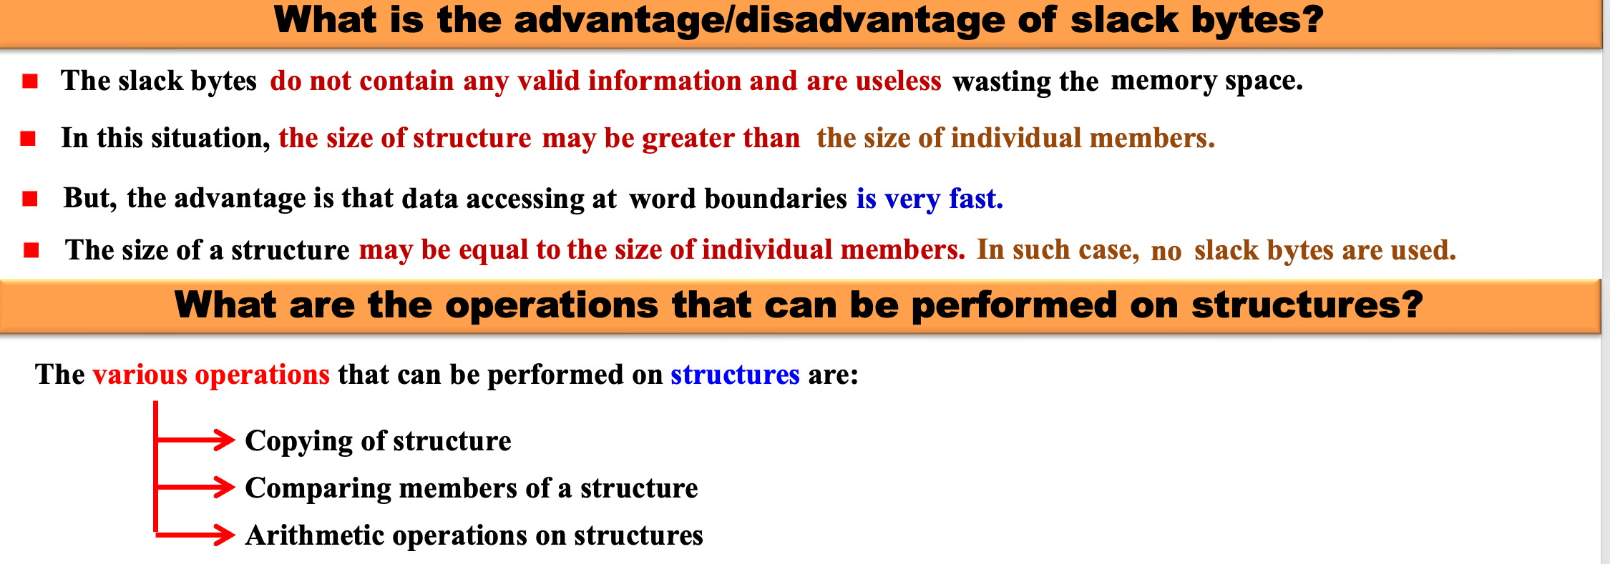
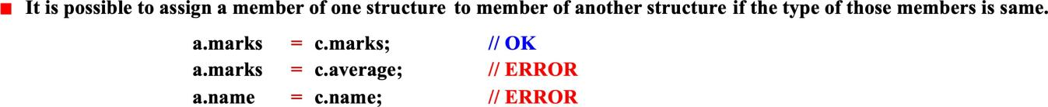
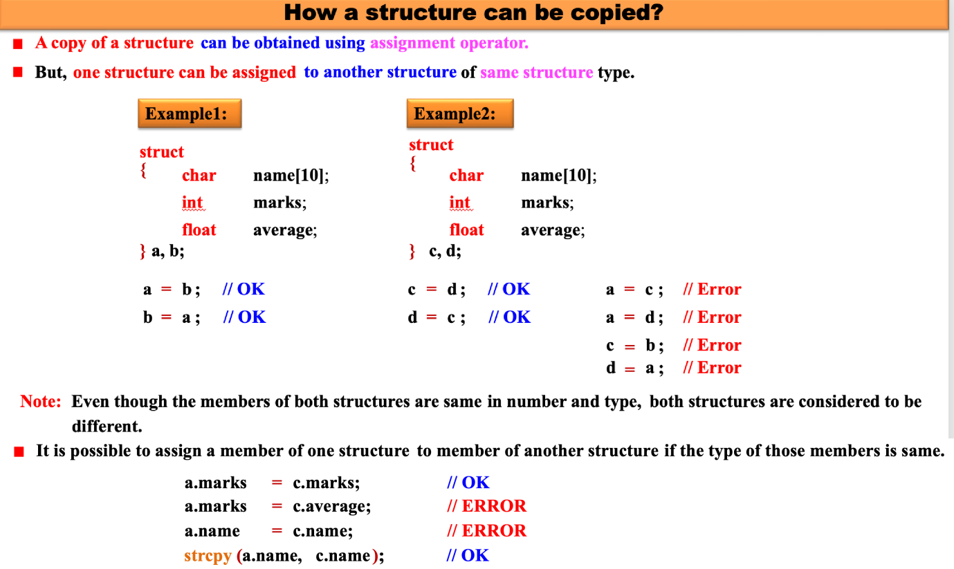

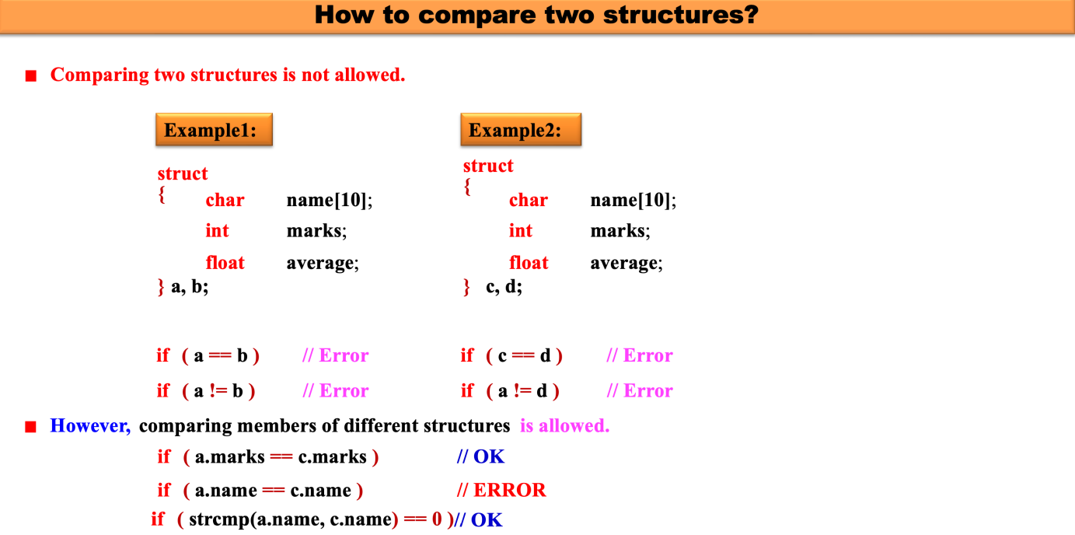
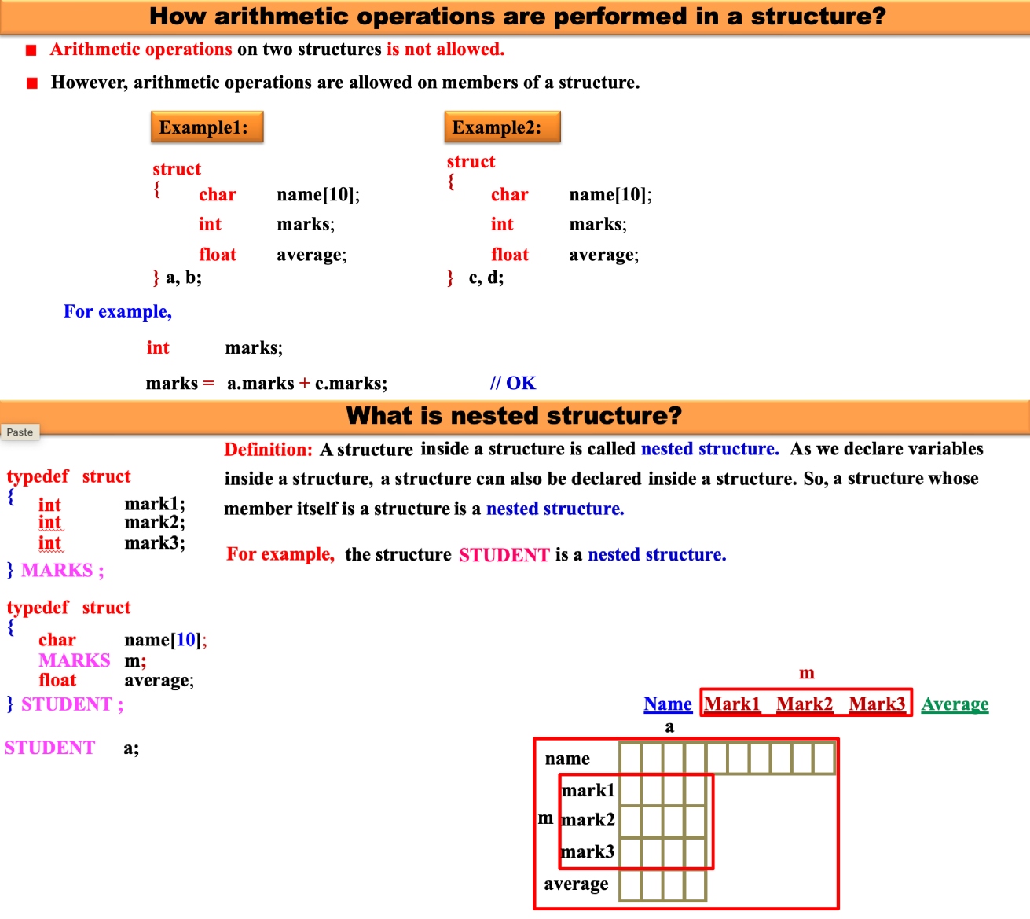

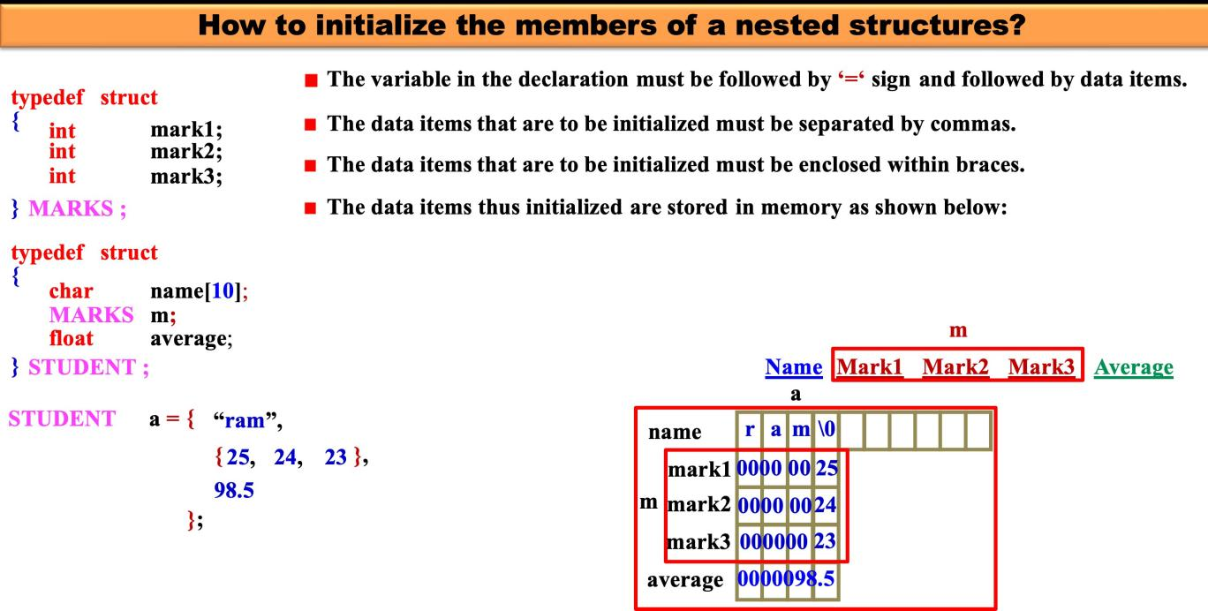
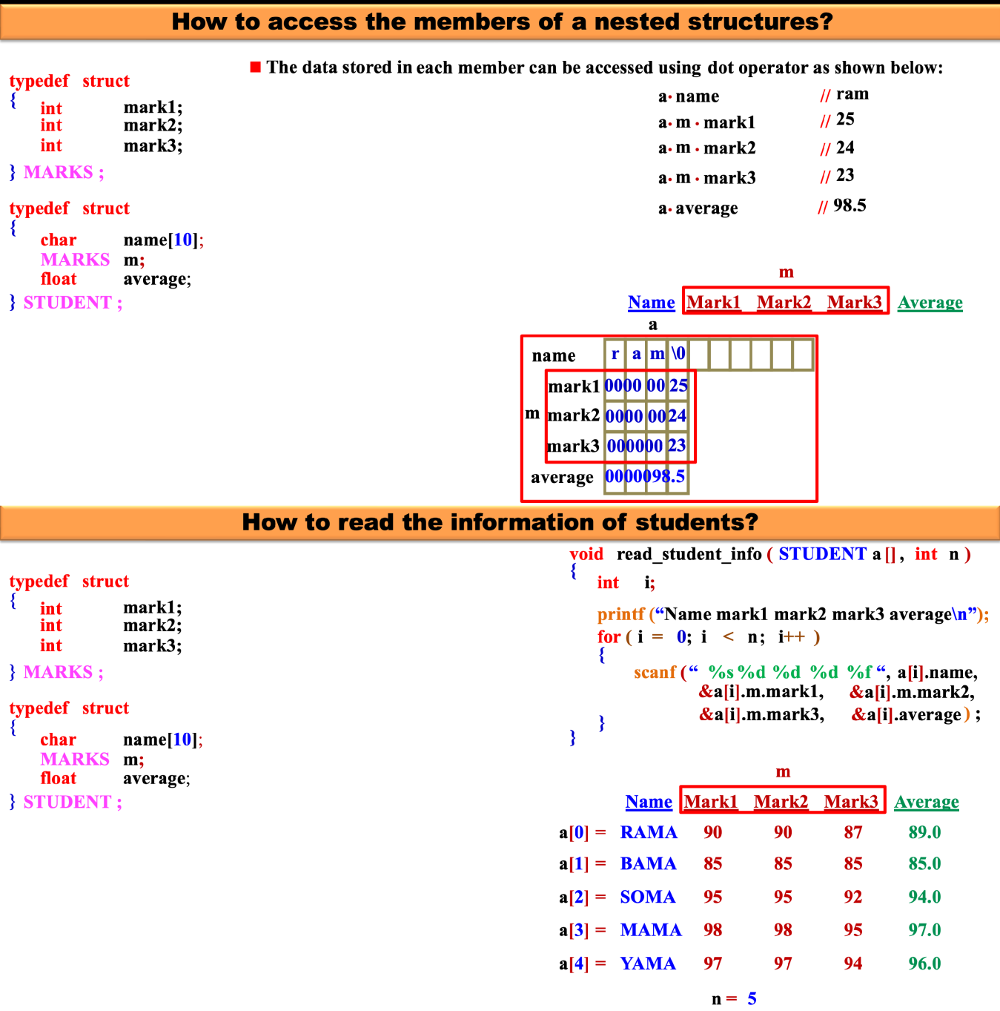

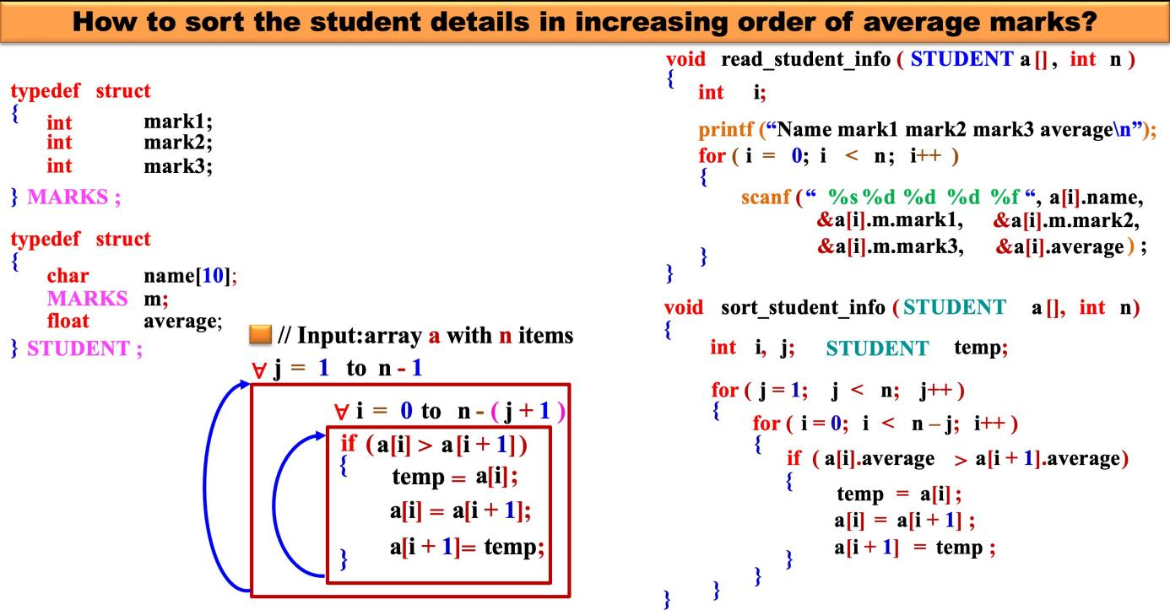
The complete program to read student inform, sort student info and to print student info can be written as shown below:

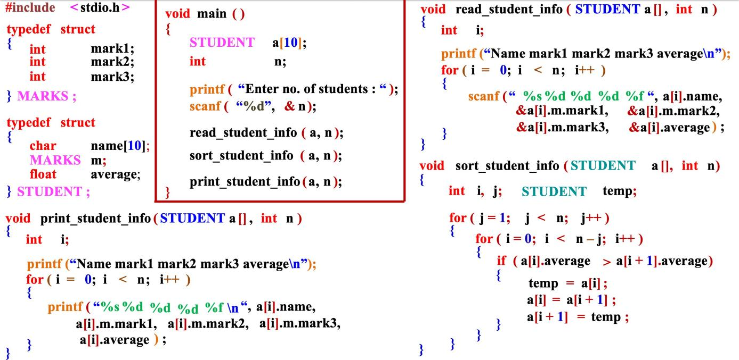
Can a structure contain array as a member name?
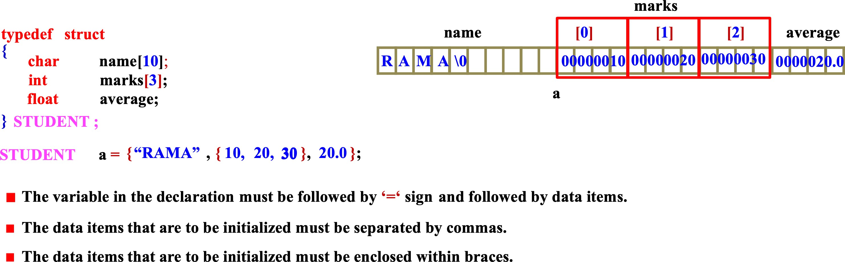
Yes. Definitely a structure can contain an array as the member name. Consider the following structure.
Note: The members “name” and “marks” are arrays inside the structure “STUDNT”.

How to initialize the members of a structure when structure has array as the member name? A structure having array as the member can be initialized as shown in program segment below:
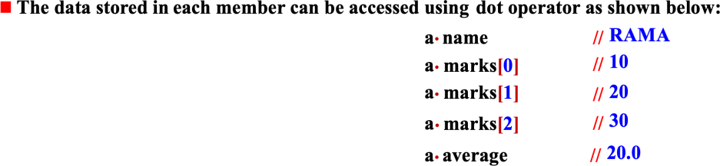

How to initialize the structures having arrays as member name? The structure having array name as member can be initialized as shown below:
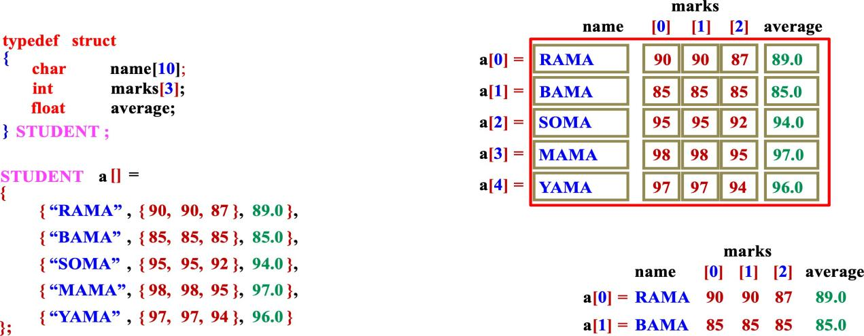
The complete program to read the student info, sort the student info and to print the student info can be written as shown below:
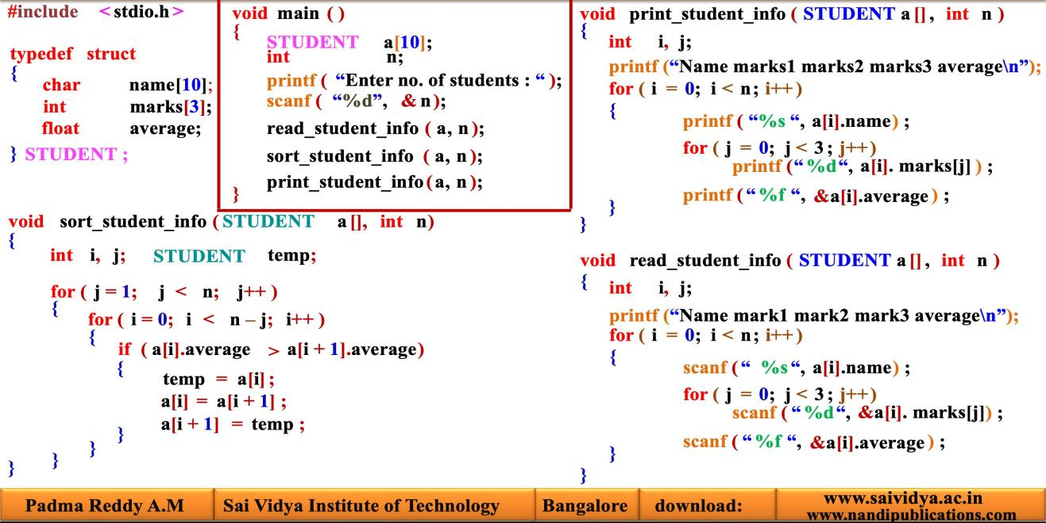

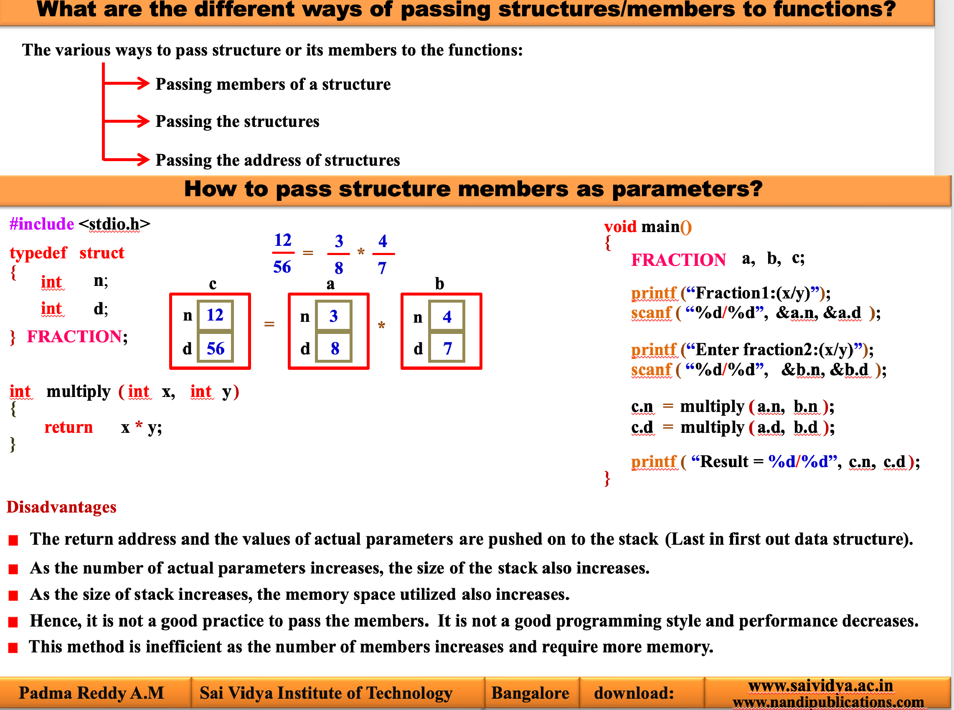

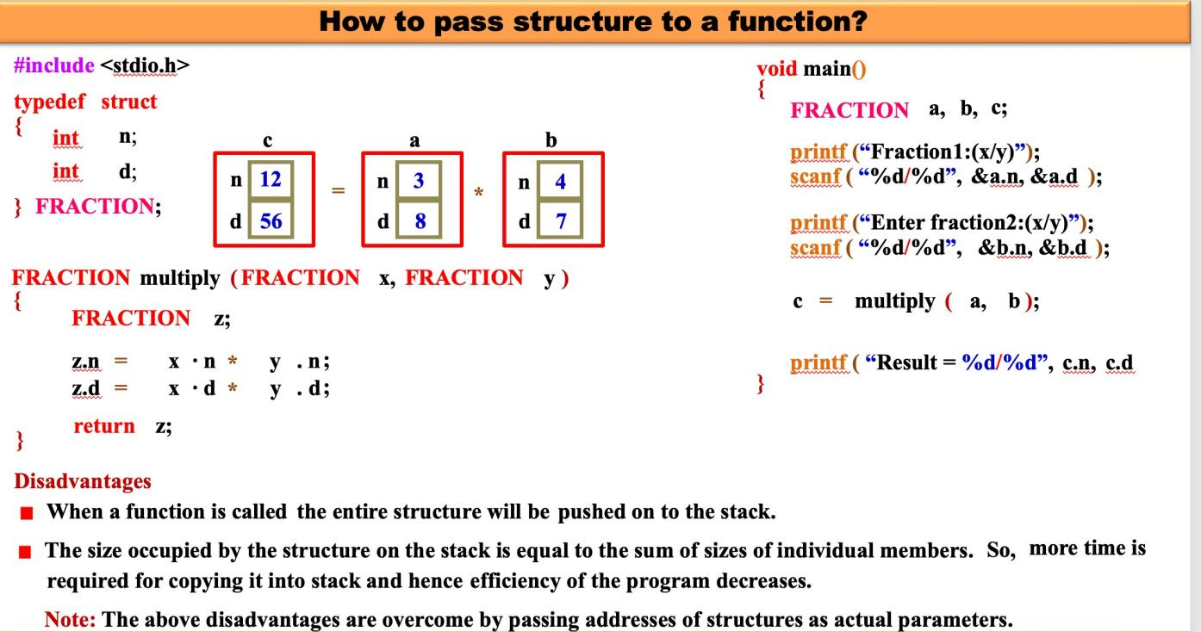
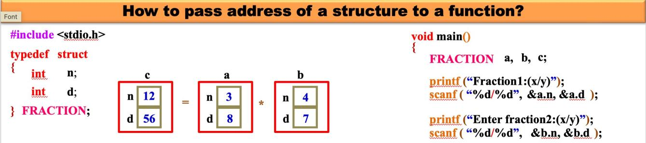

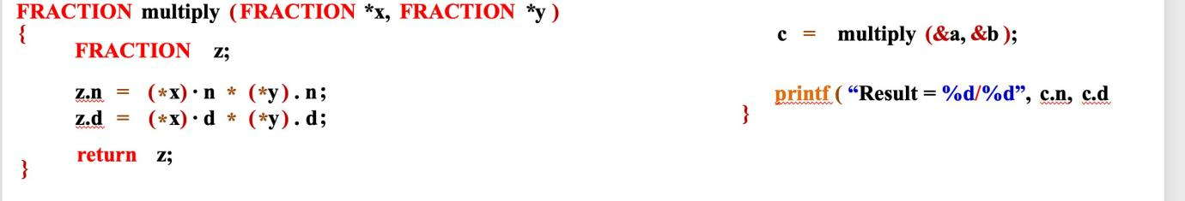
The above function multiply can also be written using array operator as shown below:
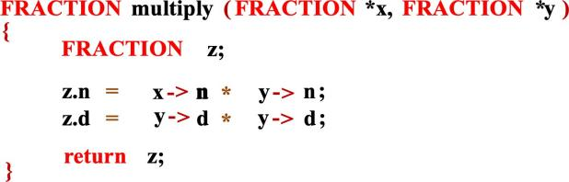
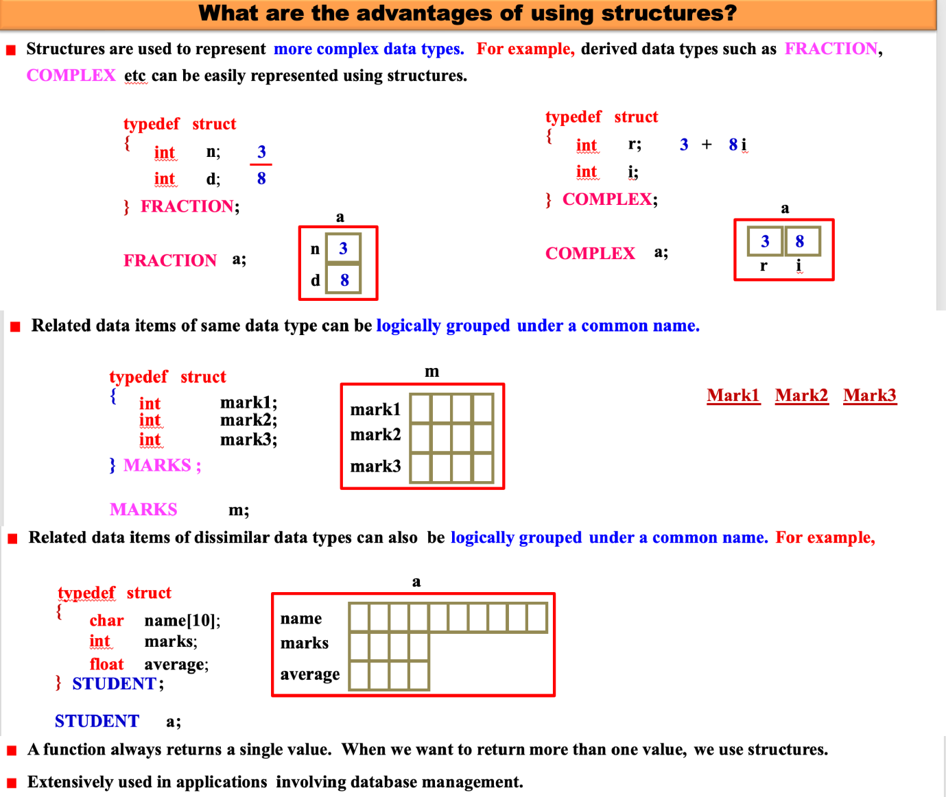

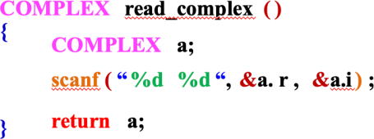
How to represent a complex number in C? A complex number 3 + 8i can be represented using structures as shown below:
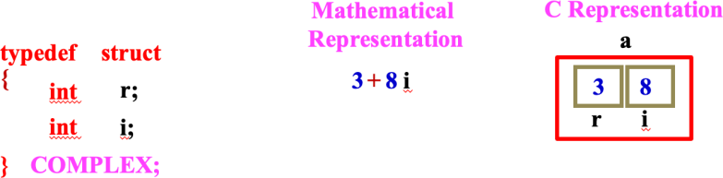
The function to read a complex number can be written as:

The function to print a complex number can be written as shown below:
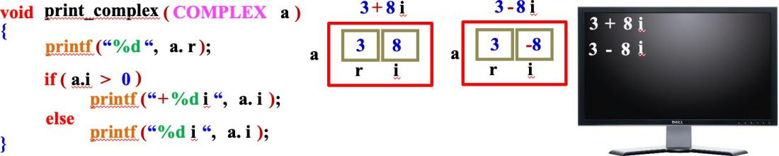

The program to read a complex number, print a complex number and to add two complex numbers can be written as shown below:
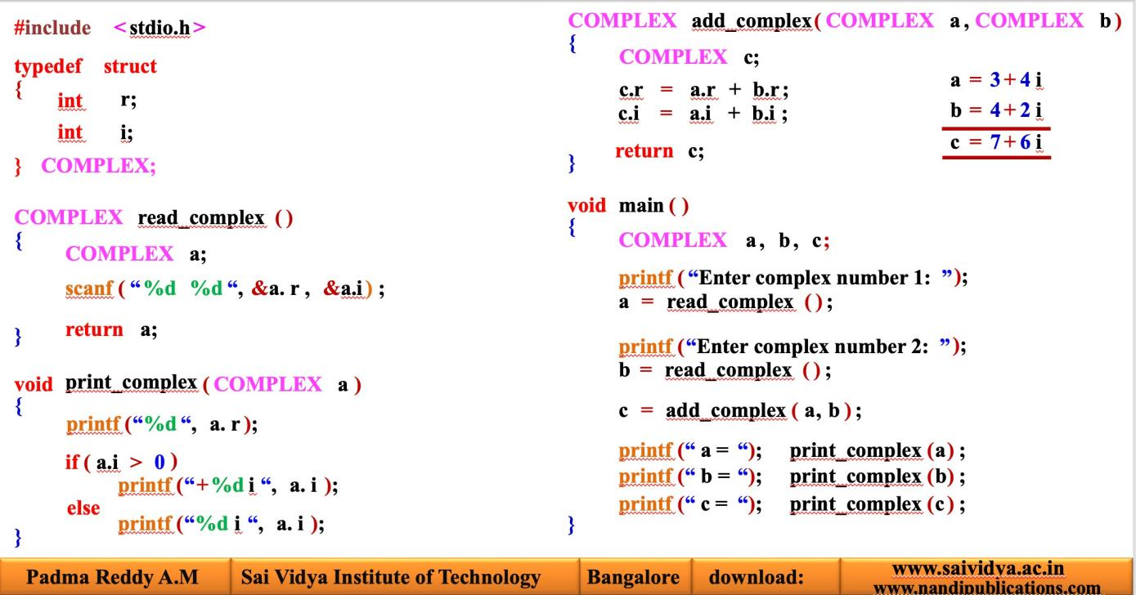
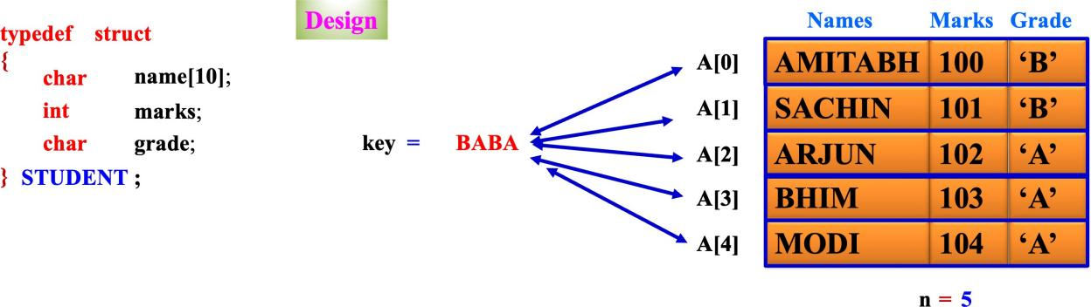
Write a C program to search for given student name in a student record consisting of name and marks The given student called “key” has to be compared with all records as shown below:
The algorithm and equivalent code can be written as shown below:
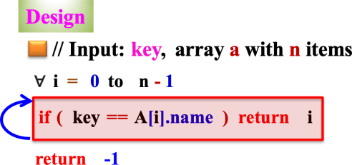
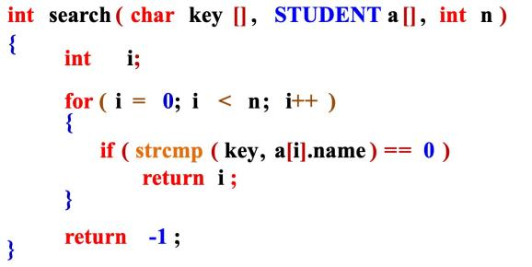
The complete C program to search for a given key in an array of student records can be written as shown below:

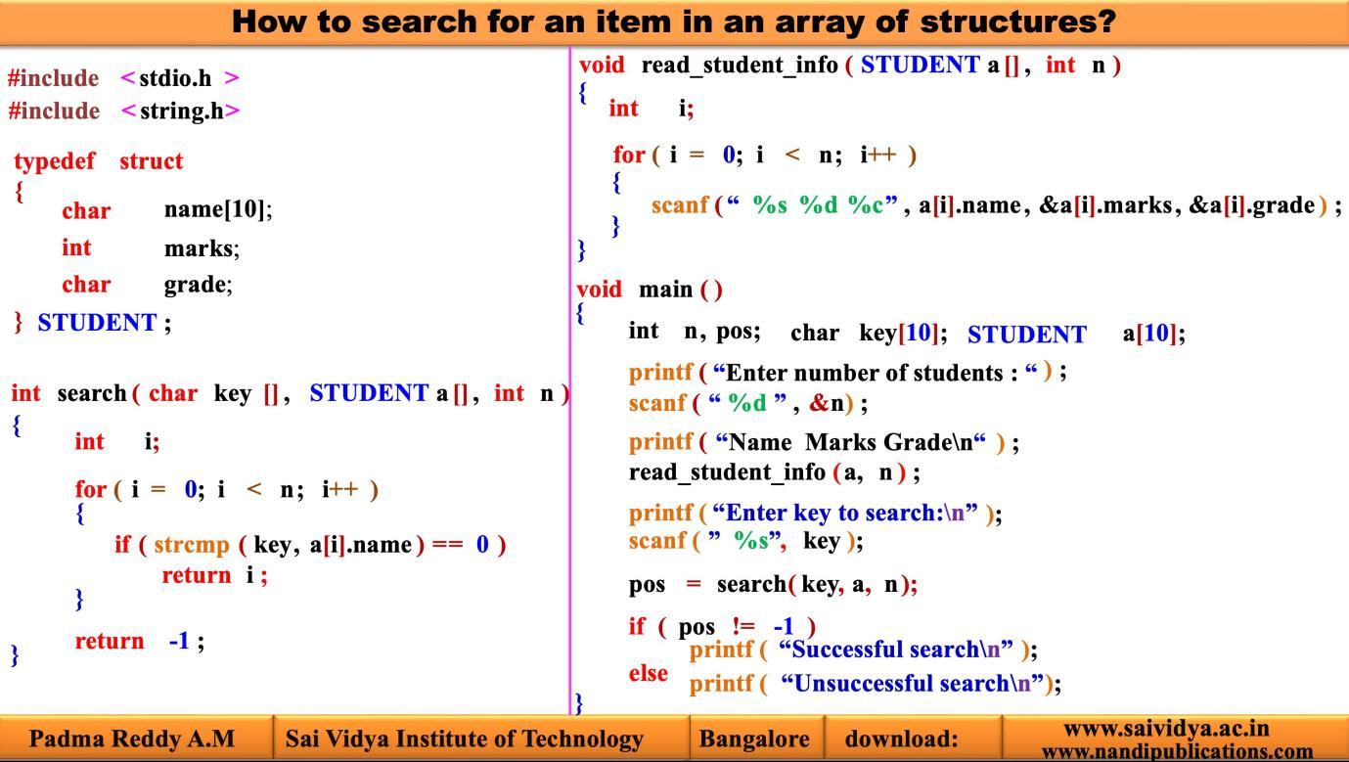

Write a program to print student information who got above average marks and who got below average marks separately.

The structure representation is shown below:
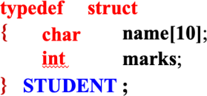

The student record where number of students n = 5 is shown below:
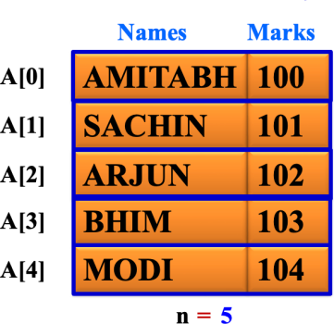
The algorithm to find the average can be written as shown below:
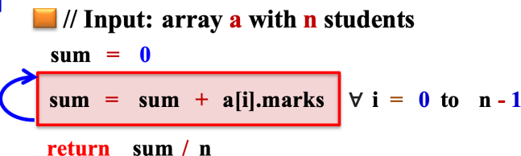

The complete program to print the student info who got more than average marks and who got less than average is shown below:

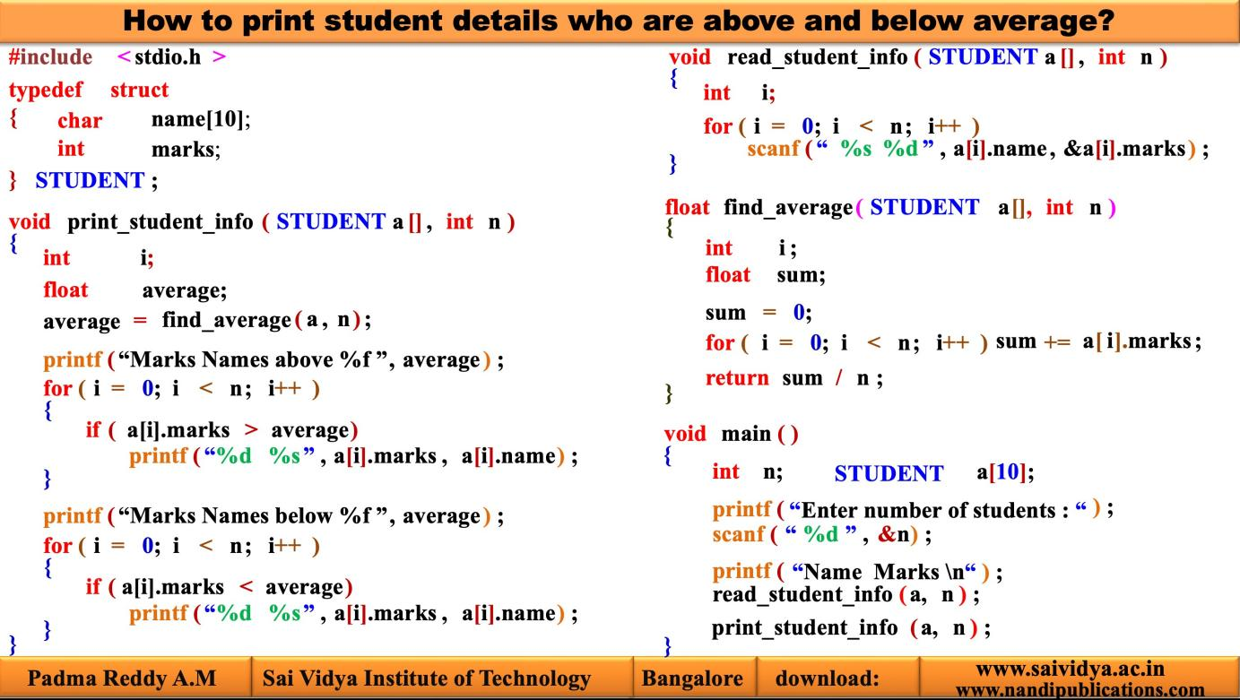
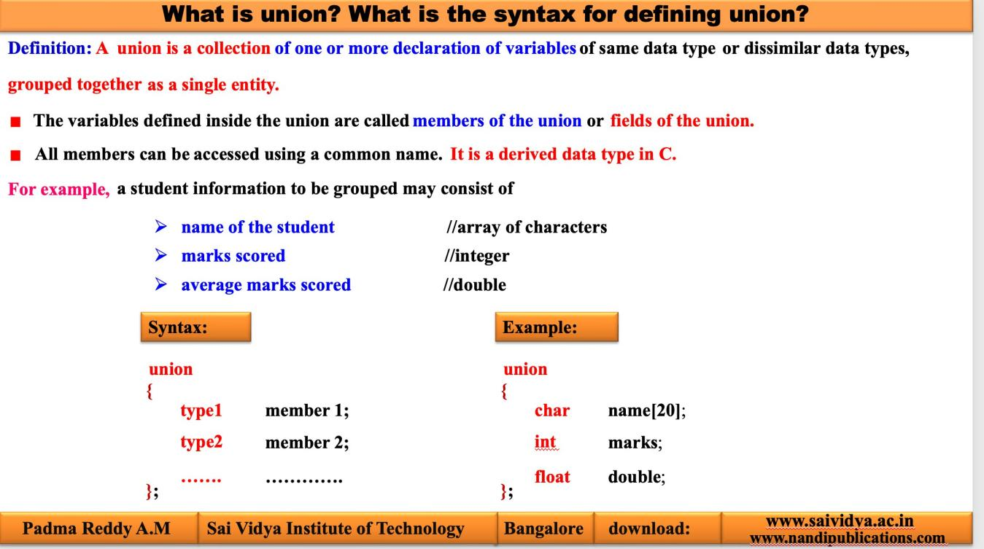

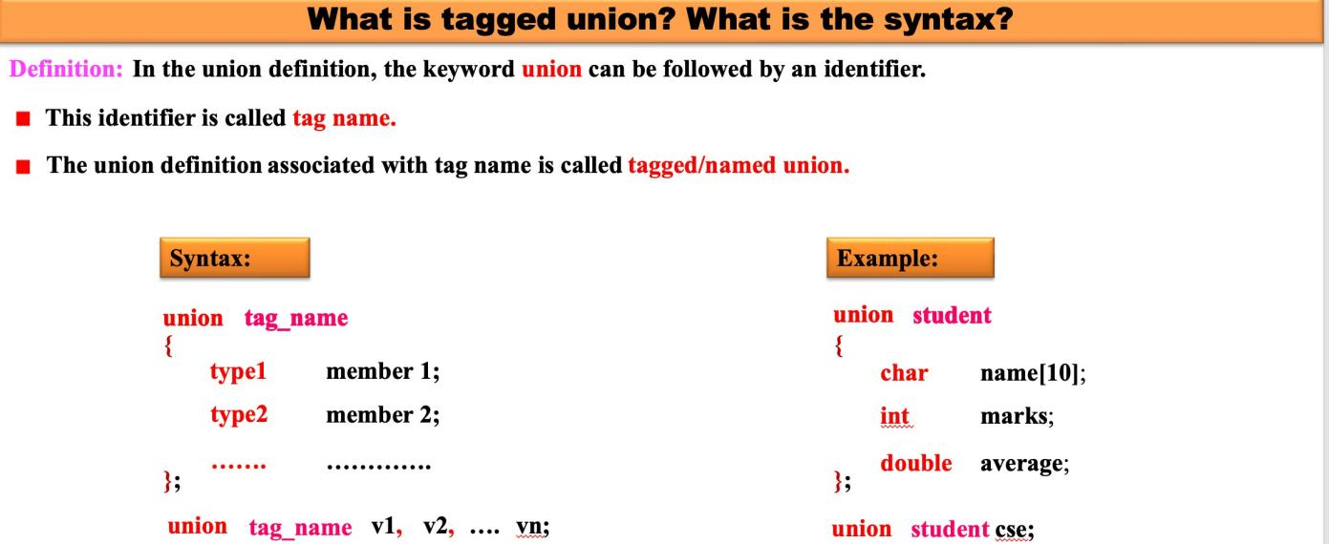

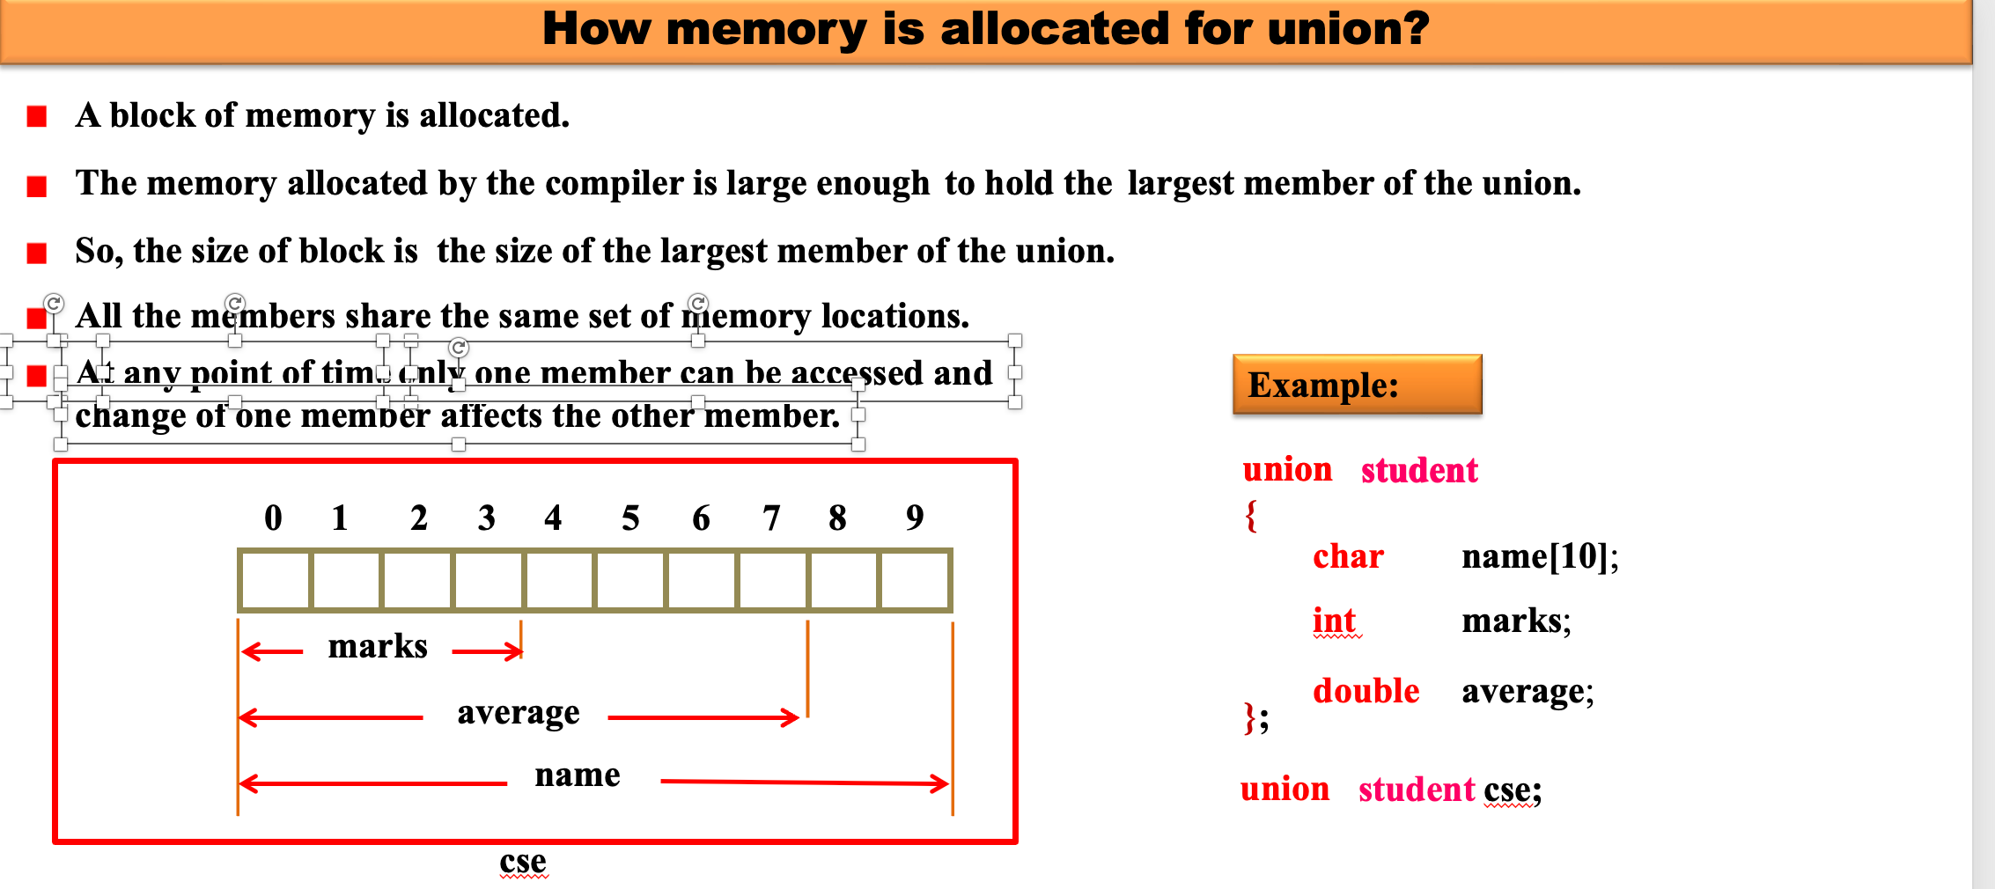
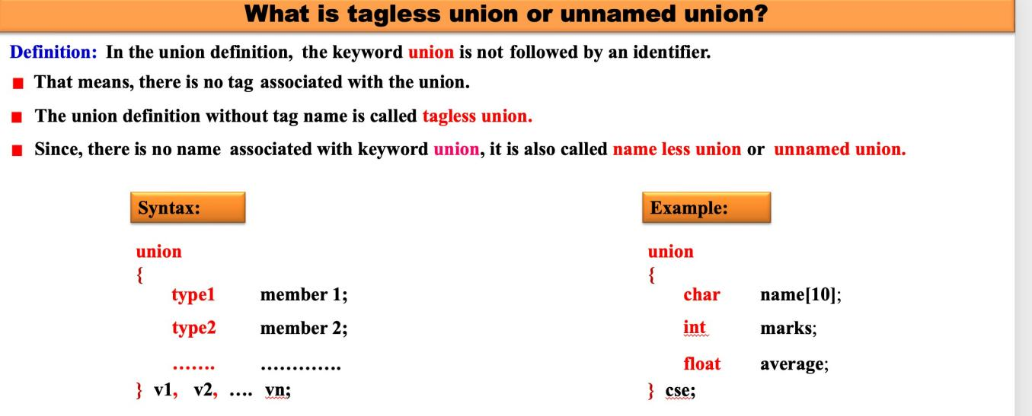
How memory is allocated?
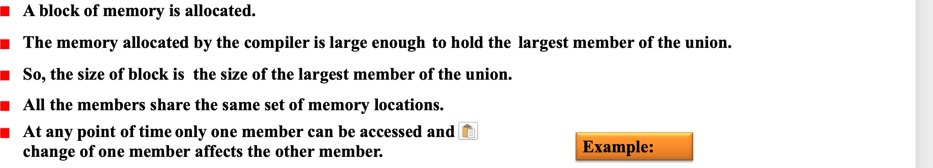

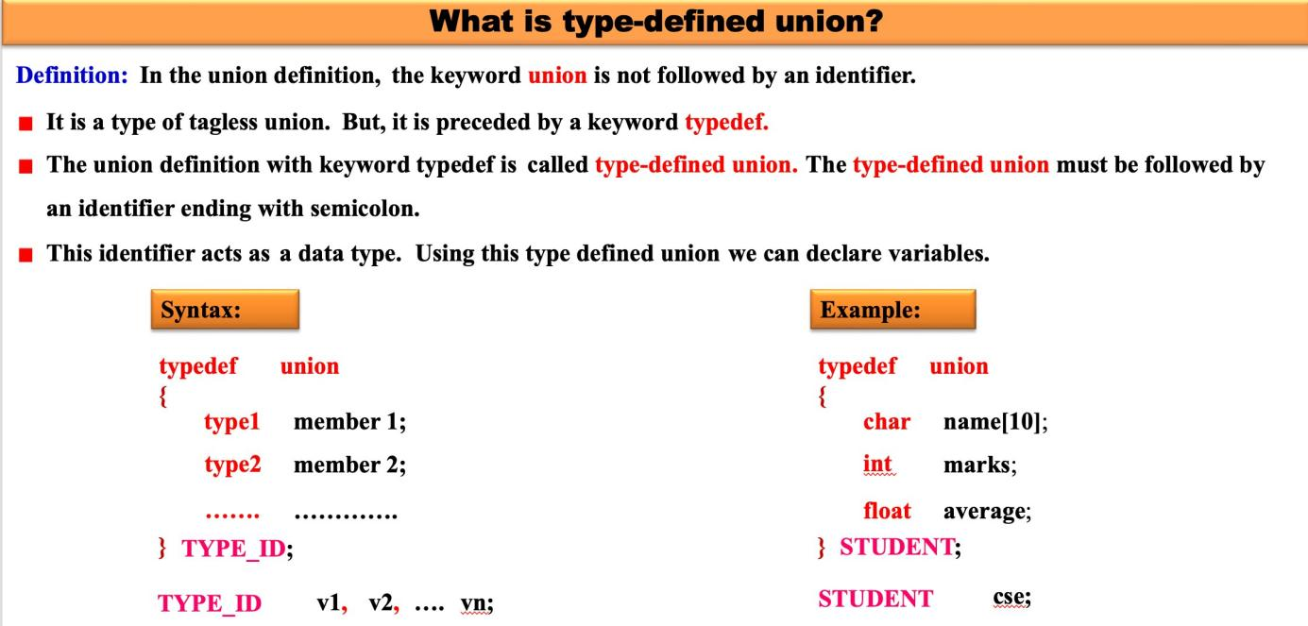
How memory is allocated?

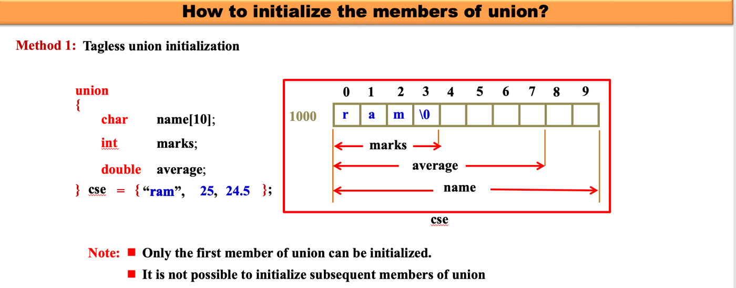
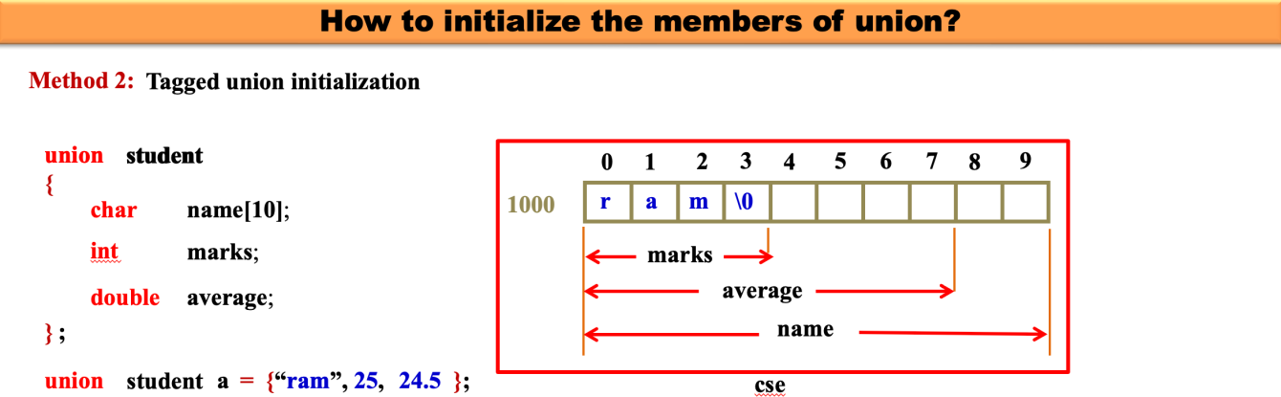

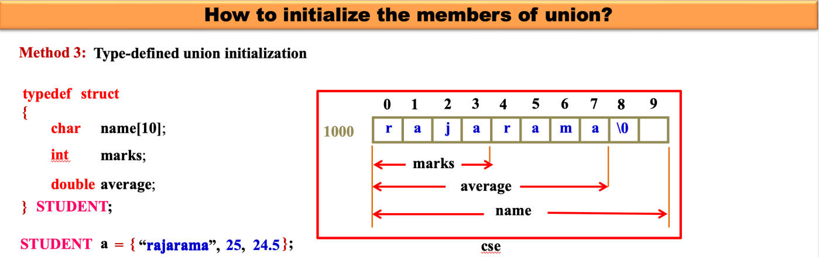
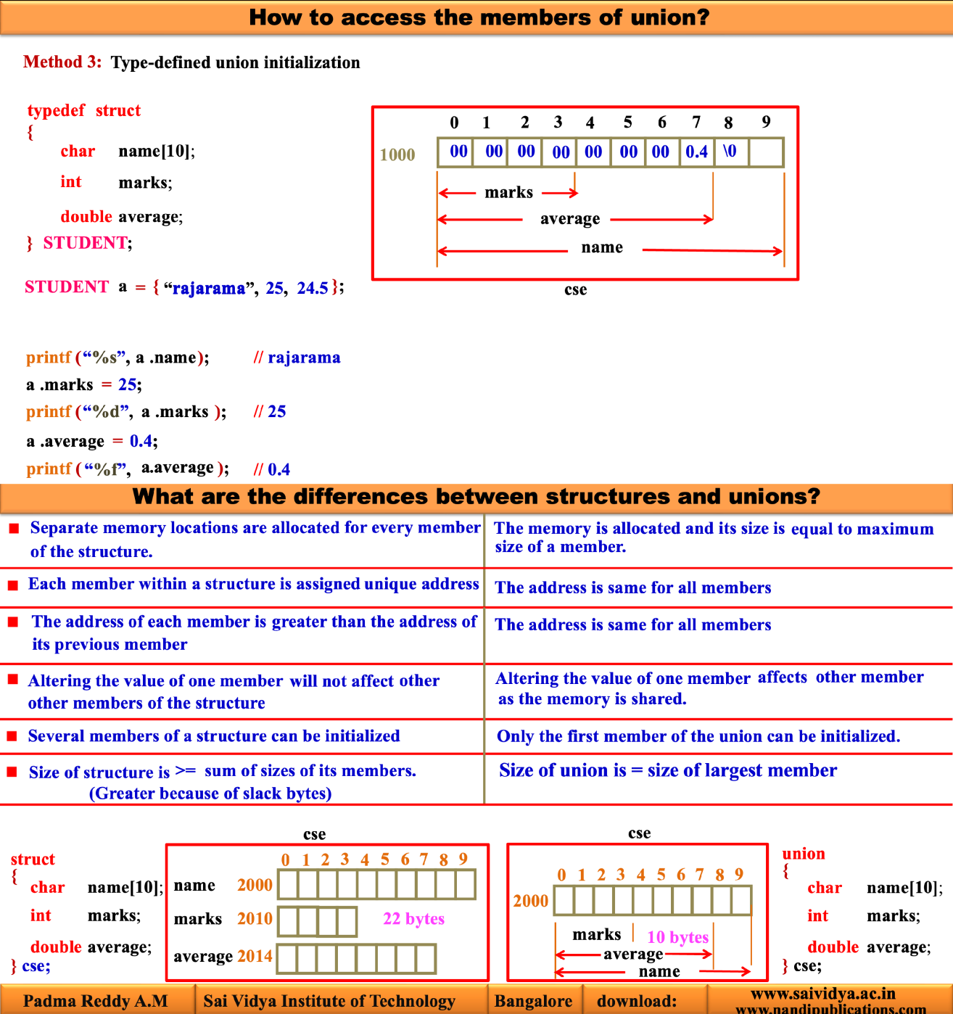

Chapter 12: Pointers
- 7 hours
- Pointers and address
- Pointers and function arguments
- pointers and arrays, address arithmetic
- character pointer and functions
- Pointer to pointer , Initialization of pointer arrays
- Understanding complex declarations
- dynamic allocation methods
- Array of pointers and programming examples.
What are we studying in this chapter?
Example 12.1: Program to print the values using variables and their addresses #include <stdio.h>
void main() a b
{
25
5
4

int a = 25;
int b = 45;
/* Accessing the data using variables */ printf(“Value of a = %d\n”, a); printf(“Value of b = %d\n”, b);
/* Accessing the address of variables */ printf(“Address of a = %d\n”, &a); printf(“Address of b = %d\n”, &b);
/* Accessing the data using de-referencing operator */

1000 1002

Value of a = 25 Value of b = 45

Address of a = 1000 Address of b = 1002

printf(“Value of a = %d\n”, *&a); Value of a = 25
printf(“Value of b = %d\n”, *&b); Value of b = 45
}
Note: Observe that the operator pair *& gets cancelled each other. So,
- *&a is same as a
- *&b is same as b
Now, the question is “Is it possible to store the address of a variable into memory?”. Yes, it is possible. As we store the data using assignment operator, we can store address of variable using assignment operator as shown below:

p = &a; // Now, the variable p contains address of variable a
x = &b; // Now, the variable x contains address of variable b
Note: Please see that, the variables p and x in above two statements are not normal variables, as they do not contain the data. Instead the variables p and x contain addresses of the data. These variables p and x which contain the addresses are called pointers or pointer variables.
Now, once we know what are pointer variables, the next question is “How to declare the pointer variables?” It is very simple and can be done as shown below:

If a variable p contains address of int variable its declaration is: | int | *p;
If a variable x contains address of float variable its declaration is: | float | *x;
If a variable y contains address of char variable its declaration is: | char | *y;
If a variable z contains address of double variable its declaration is: | double | *z;
Note: The address operator can be used with any variable that can be placed on the left side of an assignment operator. Since constants, expressions and array names cannot be used on the left hand side of the assignment and hence accessing address is invalid for constants, expressions and array names. The following are invalid:
Usage | Valid/Invalid | Reasons for invalidity
&100 | Invalid | Address of a constant cannot be obtained
&(p + 10) | Invalid | Address of an expression cannot be obtained
&(p + q) | Invalid | Address of an expression cannot be obtained
int a[10];  &a | Invalid | Address of entire array cannot be obtained
register a;  &a | Invalid | Address of a register variable cannot be obtained

N
ow, formally a pointer can be defined as shown below:
Definition: A variable that contains the address of another variable or address of a memory location is called a pointer. A pointer is also called a pointer variable.
Once we know the concept of pointers, let us see “What are the steps to be followed to use pointers?” The following sequence of steps have to be followed by the programmer:
Declare a data variable | Ex: int | a;
Declare a pointer variable | Ex: int | *p;

Steps to be followed while using pointers

Initialize a pointer variable Ex: p = &a;
Access data using pointer variable Ex: printf(”%d”,*p);

- The variables along with pointer variables have to be declared in the beginning of a function. These declarations can be in any order.
- Only point we have to remember is that before using pointers to access anything, the pointers have to be initialized with appropriate addresses.

Pointer declaration and Definition
In C language, we know that all the variables should be declared before they are used. Pointer variables also should be declared before they are used. In this section, let us see “How to declare pointer variables?” The syntax to declare a pointer variable is shown below:

For example,

type * identifier ;

Name given to the pointer variable
The asterisk (*) in between type and identifier
tells that the identifier is a pointer variable
type can be any data type such as int, float, char etc. It can be derived/user-defined data type also.

- If a variable p contains address of int variable, its declaration is: | int | *p;
- If a variable x contains address of float variable, its declaration is: | float | *x;
- If a variable y contains address of char variable, its declaration is: | char | *y;
- If a variable z contains address of double variable, its declaration is: | double | *z;
- If a variable fp contains address of FILE variable, its declaration is: | FILE | *fp;
Note: In the above declarations we say:
      - p is a pointer to an int
      - x is a pointer to a float
      - y is a pointer to a char
      - z is a pointer to a double
      - fp is a pointer to FILE (details are in FILE HANDLING: CHAPTER 14)

Example 12.2: In the declaration, the position of * is immaterial. For example, all the following declarations are same:
int *pa;
int * pa;
int* pa;

Any of the above declaration informs that the variable pa is a pointer variable and it should contain address of integer variable.
Example 12.3: Consider the multiple declarations as shown below:
int* pa, pb, pc;

Observe the following points:
- In the above declaration, most of the readers wrongly assume that the variables pa, pb and pc are pointer variables. This is because * is attached to int.
- This assumption is wrong. Only pa is a pointer variable, whereas the variables pb
and pc are ordinary integer variables.
- For better readability, the above declaration can be written as shown below:
int *pa, pb, pc;
Now, we can easily say that pa is pointer variable because of * operator, whereas
pb and pc are integer variables and are not pointer variables.
- It is still better if the variables are declared in separate lines as shown below:
int *pa;
int pb;
int pc;

Dangling pointers
In the previous section, we have seen the method of declaring a pointer variable. For example, consider the following declaration:
int *p;
This indicates that p is a pointer variable and the corresponding memory location should contain address of an integer variable. But, the declaration will not initialize the memory location and memory contains garbage value as shown below:

p Garbage value

Here, the pointer variable p does not contain a valid address and we say that it is a dangling pointer. Now, let us see “What is a dangling pointer?”
Definition: A pointer variable which does not contain a valid address is called
dangling pointer.

Example 12.4: Consider following declarations and assume all are local variables.
int *pi; /* Pointer to an integer */
float *pf; /* Pointer to a float number */
char *pc; /* Pointer to a character */

- The local variables are not initialized by the compiler during compilation. This is because, the local variables are created and used only during execution time.
- The pointer variables also will not be initialized and hence they normally contain some garbage values and hence are called dangling pointers.
- The memory organization is shown below:
…..
…..

pi pf pc
…..
…..
Garbage value Garbage value Garbage value

The pointer variables pi, pf and pc does not contain valid addresses and hence they are dangling pointers.
Note: Most of the errors in programming are due to un-initialized pointers. These errors are very difficult to debug. So, it is the responsibility of the programmer to avoid dangling pointers. Hence, it is necessary to initialize the pointer variables so that they always contain valid addresses.

Example 12.5: Consider following declarations and assume all are global variables.
int *pi; /* Pointer to an integer */
float *pf; /* Pointer to a float number */
char *pc; /* Pointer to a character */

All global variables are initialized by the compiler during compilation. The pointer variables are initialized to NULL indicating they do not point to any memory locations as shown below:
pi pf pc
NULL
NULL
NULL

12.2.4 Initializing a pointer variable
Now, the question is “How to initialize a pointer variable?” Initialization of a pointer variable is the process of assigning the address of a variable to a pointer variable. The initialization of a pointer variable can be done using following three steps:
Step 1: Declare a data variable
Step 2: Declare a pointer variable
Step 3: Assign address of a data variable to pointer variable using & operator and assignment operator
Note that the steps 1 and 2 can be interchanged i.e., we can first declare a pointer variable, then declare a data variable and then initialize the pointer variable. The three ways using which initialization can be done is described below:
Method 1: Declaring a data variable, pointer variable and initializing pointer variable in separate statements. For example, consider the following three statements:
int x; /* Step 1: x is declared as an integer data variable */
int *px; /* Step 2: px is declared as a pointer variable */
px = & x; /* Step 3: copy address of data variable to pointer variable */

Method 2:Declaring a pointer and initializing a pointer in a single statement: Using this method, the above three statements can be written as shown below:
int x;
int *px = &x;

Method 3: Declaring a data variable, pointer variable and initializing a pointer variable in a single statement: Using this method, the above two statements can be written as shown below:
int x, *px = &x;

Example 12.6: Consider the following statements:
int p, *ip;
float d, f;
ip = p; /* ERROR: The ip should contain address of a variable */ ip = &d; /* ERROR: ip is pointer to int. But, it contains address of
double variable */

ip = &p; /* OK */

Observe the following points:
- Consider the first statement: ip = p;
Here, ip is a pointer to integer. It should contain the address. But, we are not storing the address. Hence, it is an error.
- Consider the second statement: ip = &d;
Here, ip should contain address of integer variable. But, we are storing address of
float variable. So, it results in error.

Now, let us write some programs using two pointers

Example 12.7: Write a program to add two numbers using pointers

PROGRAM TRACING
- #include <stdio.h>

- void main()
- {
- int a = 10, b = 20, sum;
6
7. int *pa, *pb; 8.
- pa = &a;
- pb = &b; 11.
12. sum = *pa + *pb; 13.
Execution starts from main

a b
10
20

pa pb

sum = 10 + 20 =30

sum 30

- Output
- printf(“Sum = %d\n”, sum); Sum = 30 16.}

Example 12.8: Program to read two numbers and add two numbers using pointers

PROGRAM TRACING
- #include <stdio.h>

- void main()
- {
- int a, b, sum; 6
7. int *pa, *pb; 8.
- pa = &a;
- pb = &b; 11.
12. scanf(“%d %d”,&a, &b); 13.
- sum = *pa + *pb;
Execution starts from main
a b
20
10

pa pb
Input
10 20
a = 10 b = 20
sum = 10 + 20 =30

sum 30

- Output
- printf(“Sum = %d\n”, sum); Sum = 30 17.}
Note: After executing statement 12, the values 10 and 20 which are read from the keyboard are copied into memory locations identified by a and b. Then those values are accessed using pointer variables pa and pb, added and result is stored in the variable sum.
Note: In the statement in line 12 i.e., scanf(“%d %d”, &a, &b );
we are using &a and &b. In line 9 and 10, &a and &b are already copied into pointer variables pa and pb. So, in place of &a and &b, we can use the pointer variables pa and pb as shown below:
scanf(“%d %d”, pa, pb ); /* Since pa contains &a, pb contains &b */
Note: there is no need of writing &pa and &pb, since pa and pb already contains the addresses.

Pointers are flexible
The pointers are very flexible and can be used in variety of situations as shown below:
- A pointer can point to different memory locations
- Two or more pointers can point to same memory location

- Altering functional arguments using pointers (Pointers and function arguments)
- Functions returning pointers
- Pointers to pointers
- Arrays and pointers
- Pointer can point to a single dimensional array
- Arrays of pointers
- Pointer can point to a function
    - A pointer pointing to different memory locations
A pointer can point to different data variables by storing the address of appropriate variables. This can be explained using the following program segment:
int x = 10, y = 20, z = 30;


int *p;
10
1
p
2
3
30
20

p = &x; printf(“%d\n”, *p);
1
p = &y; printf(“%d\n”, *p);
2

p = &z; printf(“%d\n”, *p);
3
Output x

//10
y
//20
z
//30

Observe the following points:
      - ♦ The pointer variable p contains the address of x. So, output is 10
      - ♦ The pointer variable p contains the address of y. So, output is 20
      - ♦ The pointer variable p contains the address of y. So, output is 30
It is observed from above example that the pointer variable p points to different memory locations by storing the addresses of different variables. But, at any point of time, p points to only one memory location. Thus, same pointer can be pointed to different data variables.
    - Two or more pointers can point to same memory locations

Consider the statements shown below:
1 |  | p | 5000
int | *p; | q | 5002
int | *q; | r | 5004
 |  | x | 5006 | 10

Variables
Address

Garbage value Garbage value Garbage value

int *r;
int x = 10;
10
2

p = &x; | p | 5000
q = &x; | q | 5002
r = &x; | r | 5004
 | x | 5006
3
printf(“&p =%u, p = %u, *p = %d\n”,&p, p, *p); /* Output */
&p = 5000, p = 5006, *p = 10
printf(“&q =%u, q = %u, *q = %d\n”,&q, q, *q); /* Output */
&q = 5002, q = 5006, *q = 10
printf(“&r =%u, r = %u, *r = %d\n”,&r, r, *r); /* Output */
&r = 5004, r = 5006, *r = 10
Observe the following points from the above program segment:

- In the first set of instructions, memory is allocated for all pointer variables but
      - the pointers are not initialized. Hence, they contain garbage values and hence they are called dangling pointers. Only the variable x is initialized.
        - After executing the second set of statements, the pointer variables p, q and r
      - contains the address of integer variable x and logical representation is shown in above figure.
        - After executing the third set of instructions, even though various pointers have different addressed, all of them points to same set of memory locations. So, the output is 10.
3
Note: Even though the variables p, q and r have different addresses, they contain address of x only. So, different pointer variables (p, q and r in this example) contain address of one variable (x in this example). So, the value of x can be accessed and changed using the variables p, q, r and x. In general, there can be multiple pointers to a variable.

12.4.2 Pointers to Pointers
We have used pointers which directly points to data. In this section, let us see “What is pointer to a pointer?”

Definition: A variable which contains address of a pointer variable is called pointer to a pointer. For example, consider the following declarations:
int a;
int *p1;
int **p2;
- The first declaration instructs the compiler to allocate the memory for the variable
a in which integer data can be stored.
- The second declaration tells the compiler to allocate a memory for the variable p1
in which address of an integer variable can be stored.
- The third declaration tells the compiler to allocate a memory for the variable p2 in which address of a pointer variable which points to an integer can be stored. The memory organization for the above three declarations is shown below:

p2
Garbage value
p1 a
Garbage value
?

Assume the above declarations are followed by the following assignment statements:

a = 10;
p1 = &a; p2 = &p1;
The memory organization after executing the statement a = 10 is shown below:

p2
Garbage value
p1 a
Garbage value
10

The memory organization after executing the statement p1 = &a is shown below:

p2
Garbage value
p1 a

The memory organization after executing the statement p2 = &p1 is shown below:
10
p2 p1 a
10

The data item 10 can be accessed using three variables a, p1 and p2 are shown below:

a refers to the data item 10.
*p1 refers to the data item 10. Here, using p1 and one indirection operator, the data item 10 can be accessed.
**p2 refers to the data item 10. Here, using p2 and two indirection operators the data item 10 can be accessed (i.e., *p2 refers to p1 and
**p2 refers to a)

The following program illustrates the way the data item 10 can be accessed using the variable a, using a pointer variable p1 and pointer to a pointer variable p2.

Example 12.14: Program to access 10, using a variable, pointer variable and pointer to a pointer variable
#include <stdio.h> TRACING void main()

{
int a;
int *p1;
int **p2; a = 10;
p1 = &a;

p2 = &p1;
p2
Garbage value

p2
Garbage value

p2
Garbage value

p2
10
p1 a
Garbage value
?

p1 a
Garbage value
10
p1 a

10

p1 a

Output
printf(“a = %d\n”,a); a = 10
printf(“*p1 = %d\n”, *p1); *p1 = 10
printf(“**p2 = %d\n”, **p2); **p2 = 10
}

Note: If x is declared as integer, which of the following statements is true and which is false?
- The expression *&x and x are the same. // it is true
- The expression *&x and &*x are the same. // it is false illegal
Example 12.15: Given the following declarations:
int a = 5;
int b = 7;
int *p = &a;
int *q = &b;
What is the value of each of the following expressions?
  - ++a;
  - ++(*p);
  - – – (*q);
  - – –b;

Solution: The tracing of the above program segment is shown below:
/* Memory representation for the declarations */
5
7
int a = 5; a b
int b = 7;
int *p = &a;
int *q = &b; p q

/* Increment a */
6
7
++a; a b

p q

/* Access a using pointer variable p */ a b
7
7
++(*p);
p q

/* Access b using pointer variable q*/ a b
7
6
--(*q);
p q

/* Decrement b */ a b
7
5
--b;
Output a = 7 b = 5 p q
*p = 7 *q = 5

Arrays and pointers
Consider the following declaration:
int a[5] = {10, 20, 30, 40, 50};
Observe the following points:
- The compiler treats the array a as a pointer and memory is allocated for variable a.
- It then allocates 5 memory locations and address of the first memory location (say 0100) is copied into pointer variable a as shown in the diagram.
- The compiler then initializes all five memory locations with values 10, 20, 30, 40 and 50 respectively as shown in figure below:
a
0100
Note: Assuming size of integer is 2 bytes, two bytes are reserved for each memory location
&a[0] | 0100 | 10 |  | a[0]
&a[1] | 0102 | 20 |  | a[1]
&a[2] | 0104 | 30 |  | a[2]
&a[3] | 0106 | 40 |  | a[3]
&a[4] | 0108 | 50 |  | a[4]

Note: The starting address of the first byte of the array is called base address which is 0100.

Note: The address of the 0th memory location 0100 stored in a cannot be changed. So, even though a contains an address, since its value cannot be changed, we call a as pointer constant. Observe that &a[0] and a are same.

a
same
&a[0]
same
(a + 0)

To justify above points, now let us see “What is the output of the following program?”

PROGRAM TRACING
#include <stdio.h>

void main()
{
int a[5] = {10, 20, 30, 40, 50}; Output

printf(“%u %u %u\n”, &a[0], a, a+0); 0100 0100 0100
}
Note: We may get different answer in our computer. But, whatever it is, observe that the value of &a[0] or a or a+0 are same.
Now, let us see “How to access the address of each element?” The address of each item can be accessed using two different ways:

&a[0] i.e, 1000
base address with index
address operator with index
&a[1] i.e., 1002
&a[2] i.e., 1004
&a[3] i.e., 1006
&a[4] i.e., 1008
In general,
(a+0) i.e., 0100
(a+1) i.e., 0102
(a+2) i.e., 0104
(a+3) i.e., 0106
(a+4) i.e., 0108

&a[i] (a +i) where i = 0 to 4

is same as
0 to 5-1
0 to n – 1 (in general)

Note: The various ways of accessing the address of i^{th} item in an array a is shown below:

&a[i] is same as a + i
same same
&i[a] is same as i + a

So, address of a[i] can be obtained using any of the following notations:
&a[i] or a+i or i+a or &i[a]

The data in those addresses can be obtained using the indirection operator * as shown below:
*&a[i] or *(a+i) or *(i+a) or *&i[a]
Note: The pair *& get cancelled each other

a[i] i[a]
So, *(a+i) or *(i+a) or a[i] or i[a] or a[i] or i[a] are one and the same.
To justify this answer, consider the following program: #include <stdio.h>
void main()
{
 | a = 0100
&a[0] | 0100 10 |  | a[0]
&a[1] | 0102 20 |  | a[1]
&a[2] | 0104 30 |  | a[2]
&a[3] | 0106 40 |  | a[3]
&a[4] | 0108 50 |  | a[4]

int a[5] = {10, 20, 30, 40, 50};
int i = 3;
printf(“%d %d %d %d %d %d \n”, *(&a[i]), a[i], *(a+i), *(i+a), i[a], *&i[a]);
}
Output 40 40 40 40 40 40
Note: It is observed from the above example that: a[i] is same as *(a+i) denoted using pointer concept. So, any array program can be written using pointers.
    - Largest of N numbers
Consider 5 elements 10, 20, 50, 25 and 15. It is required to find the largest of these 5 numbers. Now, let us see “How to write the program to find largest of N numbers?”

Design: Assume the variable big contains 10 which is the 0th element of the array and
pos is 0 which is the position of that element. The equivalent code can be written as:

big = a[0]; /* Assume first item is big */ pos = 0; /* Store 0 as the position of 0th

item */

Initialization

Since 0th item 10 is in big, the rest of the items such as a[1], a[2], a[3] and a[4]
should be compared with big as shown in figure:

10 | 20 | 50 | 25 | 15

a
a[0]
a[1] a[2]
a[3] a[4]
if ( a[i] > big )
{
big = a[i]; pos = i;
}

i = 1 to 4.

big = 10

i = 1 to 5-1 where 5 indicates the number of elements
In general, i = 1 to n-1 where n = 5 indicates the number of elements.

So, the code can be written as shown below:

for ( i = 1; i <= n-1; i++)
{

if ( a[i] > big )
{
big = a[i]; pos = i;

Main logic

}
}

Note: When we know the program using arrays, we can easily write the program using pointers. We have seen that a[i] is same as *(a+i) or *(i+a) or i[a]. So, replace a[i] by *(a+i) to get the program using pointers.

Now, the complete program to find the largest of N elements using an array and
using pointer with indexing is shown below:

Example 12.16: Program to compute largest and its position

Using Arrays Using Pointer with indexing

#include <stdio.h>
void main()
{
int a[10], n, i, big, pos;
printf("Enter number of elements\n");
scanf("%d",&n);
printf(“Enter the elements\n”);
for ( i = 0; i <= n-1; i++)
scanf("%d",&a[i]);
big = a[0]; pos = 0;
for ( i = 1; i <= n-1; i++)
{
if ( a[i] > big )
{
big = a[i]; pos = i;
}
}
printf("Largest = %d\n”,big);
printf(“Position = %d\n", pos+1);
}

Pointers and other operators
#include <stdio.h>
void main()
{
int a[10], n, i, big, pos;
printf("Enter number of elements\n");
scanf("%d",&n);
printf(“Enter the elements\n”);
for ( i = 0; i <= n-1; i++)
scanf("%d",a+i); /* (a+i) = &a[i] */
big = *(a+0); pos = 0;
for ( i = 1; i <= n-1; i++)
{
if ( *(a+i) > big )
{
big = *(a+i); pos = i;
}
}
printf("Largest = %d\n”,big);
printf(“Position = %d\n", pos+1);
}

Like normal variables in an expression, pointer variables in expressions can also be used. If p1 and p2 are pointer variables that are declared and initialized properly, *p1 and *p2 represent the values to be manipulated. So, operations such as relational, arithmetic, logical etc., can be performed on *p1 and *p2.

Example 12.17: Valid statements with operations such as multiplication and addition

- x = *p1 * *p2; // The values pointed by p1 and p2 are multiplied
- sum = sum + *p1; // The value pointed to by p1 is added to sum
- *p1 = *p1 + 1; // value pointed to by p1 is incremented by 1

- x = *p1 /*p2; // Error: This expression is wrong because /* before p2
// is treated as beginning of the comment in C

Note: The error in the above statement can be eliminated by inserting the space between / and * as shown below:
- x = *p1 / *p2 // Correct: Since there exists space between / and *, it is
// treated as division operation not as beginning of the
// comment

Note: Even though various operations can be performed on *p1 and *p2 (since they represent the values to be manipulated), the operations are restricted on p1 and p2 since they contain only the addresses. The various operations that can be performed on pointer variables are shown below:

Operations performed on pointers
Adding an integer to a pointer Subtracting an integer from pointer Subtracting two pointers Comparing two pointers

Adding an integer to a pointer
An integer can be added to a pointer. This can be explained using the following example.

Example 12.18: Consider the following declaration: int a[5] = {10, 20, 30, 40, 50};
int *p1, *p2; p1 = a;
p2 = a;

The various valid and invalid statements are shown below:
      - p1 = p1 + 1; /* Valid: Points to next element */
      - p1 = p1 + 3; /* Valid: Points to 3rd element from p1*/
      - p1 + p2; /* Invalid: Two pointers cannot be added */
      - p1++; /* Valid: Same as p1 = p1 + 1 */

Example 12.19: Pointer arithmetic using increment operator

int a[5]={10, 20, 30, 40, 50};
int *p;
p = a; /* p points to a */
Assuming base address of a is 0100, the variable p points to first item as shown below:
a
10
20
30
40
50

float a[5]={10.555, 20, 30, 40, 50};
float *p;
p = a; /* p points to a */
Assuming base address of a is 0100, the variable p points to first item as shown below:
a

p 0100
0102
0104
0106
0108
p 0100
0104
10.555
20.0
30.0
40.0
50.0

0108
0112
0116

After executing the statement: p++;
the pointer variable p points to the next integer.

Note: Each time p++ is executed, its value will be incremented by 2 because size of integer is 2 bytes. In other words, p points to the next item.
After executing the statement: p++;
the pointer variable p points to the next floating point number.

Note: Each time p++ is executed, its value will be incremented by 4 because size of floating point number is 4 bytes. In other words, p points to the next item.

Note: In general, if p is a pointer variable pointing to an array, after executing the statement:
p++;

the pointer variable is incremented by:
- 1 for character array
- 2 for integer array
- 4 for floating point array and 8 for double and so on. In other words, the pointer points to the next item of an array.

Display array elements using pointers
Now, let us see “How to write a program to display array elements using pointer?”

Design: Consider the following array and assume p points to the beginning of the array. To start with p points to 0100 and *p refers to 10. Let us observe the outputs in various iterations shown below:

beginning of array
0100 0102 0104 0106 0108 0110
10 | 20 | 30 | 40 | 50

p p p p p p Iterations: i = 0 1 2 3 4

// 10
// 0102

// 20
// 0104

// 30
// 0106

// 40
// 0108
print 10 and increment p using 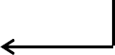
printf(“%d\n”, *p); p++;
print 20 and increment p using
printf(“%d\n”, *p); p++;
print 30 and increment p using
printf(“%d\n”, *p); p++;
print 40 and increment p using
printf(“%d\n”, *p); p++;
print 50 and increment p using
printf(“%d\n”, *p); q // 50
p++; // 0110

In general, observe that the following two statements:

printf(“%d\n”, *p); p++;

are repeatedly executed for i = 0 to 4, to get the output 10, 20, 30, 40 and 50. The C equivalent statement using for loop is shown below:
for (i = 0; i <= 4; i++) /* i <= 4 is same as i < 5 */
{
printf(“%d\n”, *p); p++;
}

The complete program is shown below:
Example 12.20: Program to display array elements using pointer #include <stdio.h>
void main()
{
int a[] = {10, 20, 30, 40, 50 };
int *p;
int i;
p = a; /* same as p = &a[0] */

for ( i = 0; i <= 4; i++)

{
10 20 30 40 50
printf("%d ",*p); p++;
}
printf("\n");
}

Sum of N numbers using pointers
In the previous example, instead of printf() within the for loop, if we use the statement
sum = sum + *p;
then we add all the elements of the array. The complete program to add n elements is shown below:

Example 12.21: Program to compute sum of elements of array #include <stdio.h>
void main()
{
int a[] = {10, 20, 30, 40, 50 };
int *p;
int i, sum;

p = a; /* point p to the first element */

sum = 0; /* Initialize sum to 0 */

for ( i = 0; i <= 4; i++)
{

sum = sum + *p; p++;
}
/* Same as */
sum = sum + *p++; or sum = sum + *(p++);

printf("Sum of all the numbers = %d\n",sum);
}

Note: Observe that by executing p++, we can point p to the next element. On similar lines by executing p--, we can point p to the previous element in an array.

Subtracting an integer from a pointer
Subtraction can be performed when first operand is a pointer and the second operand is an integer. This can be explained by considering the following example.

Example 12.22: Consider the following declaration and initialization: int a[5] = {10, 20, 30, 40, 50};
int *p1; p1 = &a[4];

The various valid and invalid statements are shown below:
      - p1 = p1 – 1; /* Valid */
      - p1 = p1 – 3; /* Valid */
      - p1--; /* Valid: Same as p1 = p1 – 1 */
      - --p1; /* Valid: Same as p1 = p1 – 1 */
      - p1 = 1 – p1; /* Invalid: The first operand should be a pointer

Example 12.23: Write a program to display array elements using pointer from last element to first element.

Note: As we execute p++, pointer variable p points to next element, if we execute p--, pointer variable p points to the previous element.
Design: To get the array elements in reverse order, point the variable p to point to the end of the array and replace p++ by p– – in the previous program. The complete program is shown below:

#include <stdio.h>

void main()
{
int a[] = {10, 20, 30, 40, 50 };
int *p;
int i;
p = &a[4]; /* point p to the last element*/

for ( i = 0; i <= 4; i++)
{
printf("%d ",*p); p
p--;
}
printf("\n");
a
0100
50
40
30
20
10
0102
0104
0106
0108

Output

} p points to previous element after executing p-- and items are accessed from bottom to top.
50 40 30 20 10

Subtracting two pointers
If two pointers are associated with the same array, then subtraction of two pointers is allowed. But, if the two pointers are associated with different arrays, even though subtraction of two pointers is allowed, the result is meaningless.
Consider the following declaration and initialization: int a[5] = {10, 20, 30, 40, 50};
int *p1;
int *p2;
float *f;
p1 = a; /* same as p1 = &a[0] */ p2 = &a[4];
The various valid and invalid statements are shown below:
- p2 – p1; /* Valid */
- p1 – p2; /* Valid */
- f – p1; /* Invalid: Since type of both operands is not same */
The memory map for the above declaration is shown below:
p1 4 elements away p2
0100 0102 0104 0106 0108
10 | 20 | 30 | 40 | 50

Note: Observe following facts from above figure:
- p2 has an address 0108 and p1 has address 0100.
- But, p2 – p1 is not 0108-0100. Actually, it is (0108-0100)/sizeof(int) i.e., (0108-0100)/2 = 4
- So, p2 – p1 gives us 4 which indicates that p2 is at a distance of 4 elements away from p1.
- So, p2 – p1 +1 gives the number of elements in the array

Comparing two pointers
If two pointers are associated with the same array, then comparison of two pointers is allowed using relational operators. But, if the two pointers are associated with different arrays, even though comparisons of two pointers is allowed, the result is meaningless.

Consider the following declaration and initialization:
int a[5] = {10, 20, 30, 40, 50};
int *p1;
int *p2;
float *f;
p1 = a; /* or p1 = &a[0] */ p2 = &a[4];
The various valid and invalid statements are shown below:
- p2 != p1; /* Valid */;
- p1 == p2; /* Valid */;
- p1 <= p2; /* Valid */;
- p1 >= p2; /* Valid */
- f != p1; /* Invalid: Since type of both operands is not same */
Note: Multiplying and dividing a pointer variable with any other variable or integer is not allowed.
Now, let us see “How to write a program to display array elements by comparing of two pointers?”
Design: Let us use two pointers p and q where p points to the first element of array a
and q points to the last element of array a as shown below:
p q
0100 0102 0104 0106 0108
a
10 | 20 | 30 | 40 | 50

Observe from the above figure that as long as p <= q, value pointed to by p can be printed and updated using the following statements:
while (p <= q)

{
printf("%d ",*p); p++;
}
Output
10 20 30 40 50

So, the complete program is shown below:

Example 12.24: Program to display array elements by comparing pointers

#include <stdio.h>
void main()
{
int a[] = {10, 20, 30, 40, 50 };
int *p;
int *q;
p = &a[0]; /* point p to the first element */
q = &a[4]; /* point q to the last element*/
while (p <= q) /* Comparing two pointer values */
{
10 20 30 40 50
printf("%d ",*p); p++;
}
printf("\n");
}

Note: Two pointer subtractions and two pointer comparisons are generally performed if both the pointers point to the same array.

  - Passing an array to a function / character pointer and functions
As we pass various parameters to functions, we can also pass name of an array as a parameter. Note: Name of an array is a pointer to the first element. So, when we pass an array to a function we should not use the address operator. The syntax of a function call is:
function_name (a); /* Here a should have been declared as array */ The two ways of declaring and using the array in the called function are:

- using pointer declaration
- using array declaration

void function_name(int a[])
{
/* ith item can be accessed using a[i]
*/
}
void function_name(int *a)
{
/* ith item can be accessed using *(a+i)
*/
}

Note: Easier way of writing a program using pointers
- write a program using arrays i.e., may be using a[i] or a[j] etc.
- Then replacing a[i] by *(a+i) and a[j] by *(a+j) we get the program using pointers.
Now, using the above technique, any array program can be converted into a program using pointers.

strlen(str) – String Length
Consider the function to find the length of the string (Refer example 10.11, section 10.5.1 for design details). Various versions of the functions are written side by side to show the difference:

Example 12.25: Function returning the string length

Using arrays Using pointers

int my_strlen(char str[])
{
int i = 0;

/* compute the length */
while (str[i] != ‘\0’) i++;
int my_strlen(char *str)
{
int i = 0;
/* compute length */
while (*(str +i) ) i++;
int my_strlen(char *str)
{
char *ptr = str;

while (*ptr++)
;

return ptr-str;

return i;
}
return i; }
}

The C program to access any of the above functions can be written as shown below:

Example 12.26: Program using the user-defined function my_strlen()

#include <stdio.h>
/* Include: Example 12.25: to compute the length */
void main()
{

char str[20];
int i;
printf("Enter the string\n");
gets(str);
i = my_strlen(str) ;

printf("Length = %d\n", i);
}

Input
Enter the string Rama
i = 4 Output Length = 4

strcpy(dest, src) – string copy
Now, let us write a function to implement strcpy (Refer section 10.5.2, example 10.14 for design details). So, the final function to copy the contents of source string src to destination string dest using arrays as well as using pointers is shown below:

Example 12.27: Function to copy string src to string dest using 3 methods.

Using arrays Using Pointers

void my_strcpy(char dest[], char src[])
void my_strcpy(char *dest, char *src)
{
/* copy the string */
while ( *src != ‘\0’)
*dest++ = *src++;
/* attach null character at end */
*dest = ‘\0’;
}
Note: Following is most efficient one
void my_strcpy(char *dest, char *src)
{
while (*dest++ = *src++)
;
}
{
int i = 0;

/* Copy the string */
while (src[i] != ‘\0’)
{
dest[i] = src[i]; i++;
}

/* Attach null character at the end */ dest[i] = ‘\0’;
}

Note: Observe the null statement “;” in the third version of my_strcpy. It does nothing. The condition in the while loop i.e., *dest++ = *src++ is repeatedly executed and each character of the source is copied into destination including ‘\0’. Once ‘\0’ is reached, the condition fails and control comes out of the loop. The complete program which uses the user defined function is shown below:

Example 12.28: Program using the user-defined function my_strcpy() #include <stdio.h>
/* Include: Example 12.27 to compute the length */
void main()
{

char src[20], dest[20];
printf("Enter the string\n");
gets(src); my_strcpy(dest, src);
printf("Dest string = %s\n", dest);
}
TRACING
Enter the string RAMA
dest = “RAMA” Dest string = RAMA

strcmp(s1, s2) – string compare
This function is used to compare two strings. The design details are given in section 10.5.7, example 10.25. The function using arrays and pointers are given side by side below:

Example 12.29: Function to compute two strings.

Using arrays Using Pointers

int my_strcmp(char s1[], char s2[])
{
int i;
i = 0;
while (s1[i] == s2[i])
{
if (s1[i] == ‘\0’) break;
i++
}
int my_stcmp(char *s1, char *s2)
{

while (*s1 == *s2)
{
if (*s1 == ‘\0’) break;
s1++, s2++;
}

return s1[i] – s2[i];
}
return *s1 - *s2;
}

The above function returns one of the following values:
- zero if s1 = s2
- positive if s1 > s2
- negative if s1 < s2
The complete program showing the usage of my_strcmp is shown below:

Example 12.30: C program showing the usage of my_strcmp

#include <stdio.h>
/* Include: example 12.29: Function my_strcmp */
void main()
{
char s1[] = "RAMA";
char s2[] = "KRISHNA";
int difference;
difference = my_strcmp(s1, s2);
if (difference == 0)
printf("String s1 = string s2\n");
else if (difference >0)
printf("String s1 > string s2\n");
else
printf("String s1 < string s2\n");
}

Understanding complex declarations
Note that it is very difficult to interpret and understand the declarations especially related to pointers. To read and understand the complicated declarations, we can follow the right-left rule. Now, let us see “What is right-left rule?”
Definition: The right-left rule can be stated as follows:
- Start with the identifier in the center
start
end
identifier
of declaration
- Read the declarations in a spiral manner once going right and then left, again right and left and so on till all entities are read i.e, right-left reading of each symbol is done alternatively spinally. This concept can be represented pictorially as shown on the right hand side.

Example 12.31: Interpret the declaration: int x. The declaration can be pictorially represented as shwon below:
Note: Read and interpret the entity in each box in the direction of the arrow mark along with labels.
x
end
is an
start
int

i.e., x is an int. In other words, x is an integer

Example 12.32: Interpret the declaration: int *p. The declaration can be pictorially represented as shwon below:
to
Reading in the direction of arrow along with the labels we have:
is a
end
int
* p
start

p is a * to int
i.e., p is a pointer to an integer [By reading * as pointer, int as integer]
Example 12.33: Interpret the declaration: int a[10]. The declaration can be pictorially represented as shwon below:
is an array of

end
a
[10]

start
int
Reading in the direction of arrow along with the labels we have:

a is an array of 10 int
i.e., a is an array of 10 integer
[By reading int as integer]
Example 12.34: Interpret the declaration: int *p[5]. The declaration can be pictorially represented as shwon below:
to
[5]
is an array of
p

start
*

end

int
Reading in the direction of arrow along with the labels we have:
p is an array of 5 * to int i.e., p is an array of 5 pointers to integers where * is pointer, int is integer

Example 12.35: Interpret the declaration: int (*p) [5]. The declaration can be pictorially represented as shwon below:

to an array of
end
is a
start
[5]
*
p
int
Note: Preference is given for the expression withing parantheses. Reading in the direction of arrow along with the labels we have:
p is a * to an array of [5] int i.e., p is a pointer to an array of 5 integers where * is pointer, int is integer

Example 12.36: Interpret the declaration: int a (int b). The declaration can be pictorially represented as shwon below:
is a function
end
a
(int b)

start
int
with b as integer parameter

returning
Note: If an identifier is followed by (….), it indicates a function call or function declaration. So, reading in the direction of arrow along with the labels we have:
a is a function with (int b) and returning int
i.e., a is a function which accepts b an integer as a parameter and returning an integer

Memory allocation functions
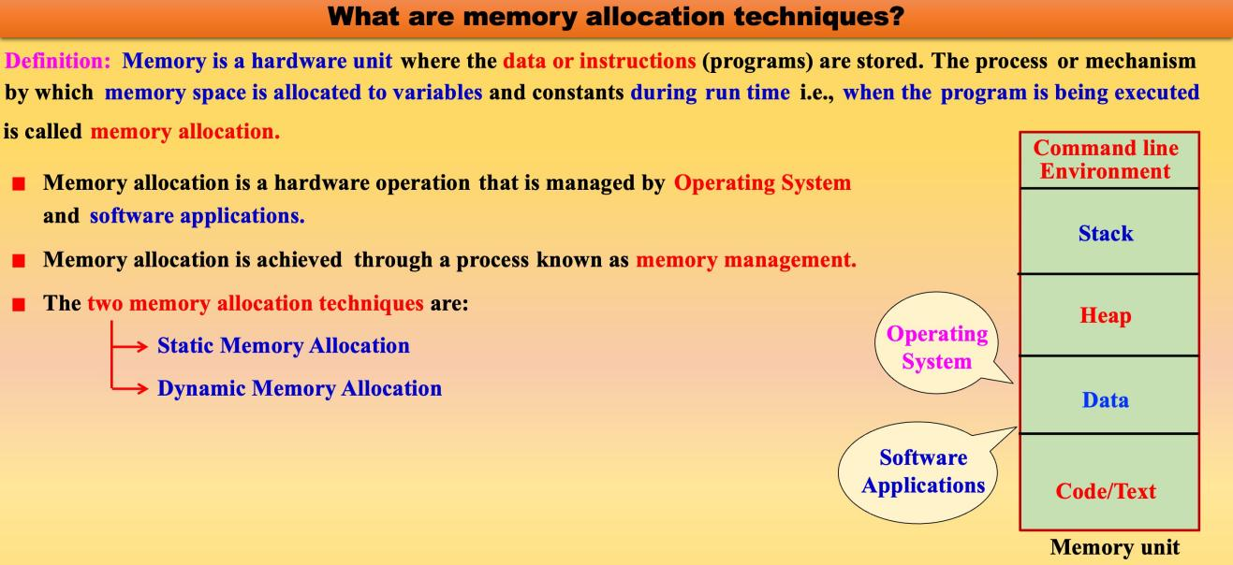

Now, let us see “What is static memory allocation?”
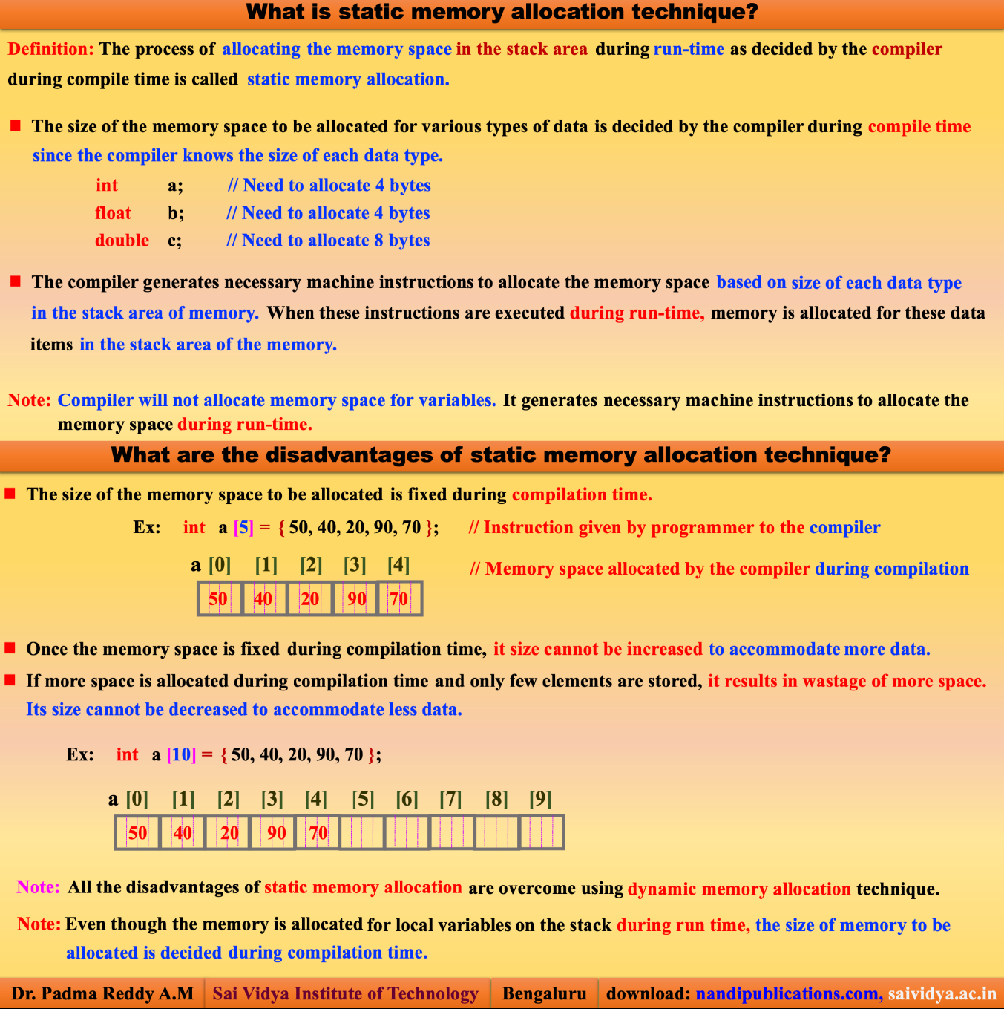

Note: If there is an unpredictable storage requirement, then static allocation technique is not at all used. This is the point where the concept of dynamic allocation comes into picture. Now, the question is “What is dynamic memory allocation?”

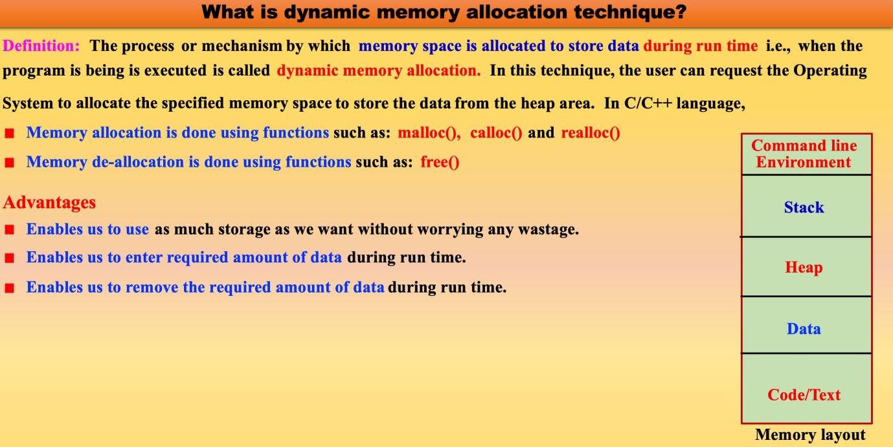
Now, let us see “What are the differences between static memory allocation and dynamic memory allocation?” The various differences between static allocation and dynamic allocation technique are shown below:
Static allocation technique Dynamic allocation technique

1. Memory is allocated during compilation time | 1. Memory is allocated during execution time
2. The size of the memory to be allocated is fixed during compilation time and cannot be altered during execution time | 2. When required memory can be allocated and when not required memory can be de-allocated
3. Used only when the data size is fixed and known in advance before processing | 3. Used only for unpredictable memory requirement.
4. Execution is faster, since memory is already allocated and data manipulation is done on these allocated memory locations | 4. Execution is slower since memory has to be allocated during run time. Data manipulation is done only after allocating the memory.
5. Memory is allocated either in stack area (for local variables) or data area (for global and static variables). | 5. Memory is allocated only in heap area

6. Ex: arrays | 6. Ex: Dynamic arrays, linked lists, trees

Now, let us see “What are the various memory management functions in C?” Th
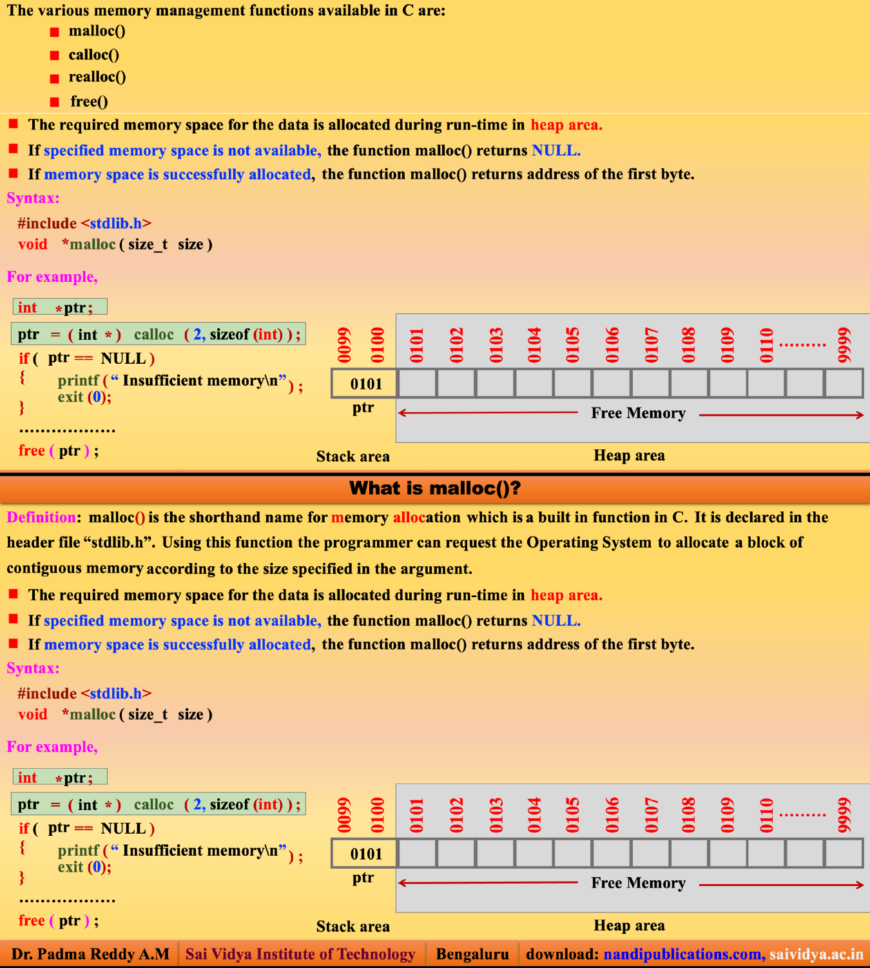

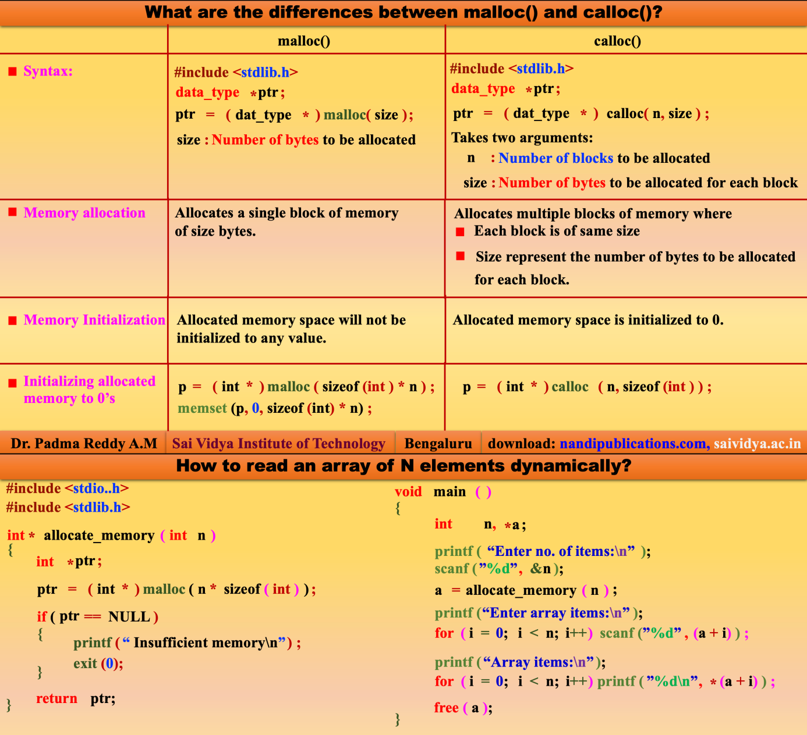
    - malloc(size)
Now, let us see “What is the purpose of using malloc?” This function allows the program to allocate memory explicitly as and when required and the exact amount needed during execution. This function allocates a block of memory. The size of the block is the number of bytes specified in the parameter. The syntax is shown below:
#include <stdlib.h> /* Prototype definition of malloc() is available */
……..
ptr = (data_type *) malloc(size);
…….
where
- ptr is a pointer variable of type data_type

- data_type can be any of the basic data type or user defined data type
- size is the number of bytes required
Observe the following points:
      - On successful allocation, the function returns the address of first byte of allocated memory. Since address is returned, the return type is a void pointer. By type casting appropriately we can use it to store integer, float etc.
      - If specified size of memory is not available, the condition is called “overflow of memory”. In such case, the function returns NULL. It is the responsibility of the programmer to check whether the sufficient memory is allocated or not as shown below:
void function_name()
{
……..
ptr = (data_type *) malloc(size);
if (ptr == NULL)
{
printf(“Insufficient memory\n”); exit(0);
}
……..
……..
}

Example 12.37: Program showing the usage of malloc() function

#include <stdio.h> #include <stdlib.h>
void main()
{
TRACING

Execution starts from here

int i,n;
int *ptr;
printf("Enter the number of elements\n");
scanf("%d",&n);
ptr = (int *) malloc (sizeof(int)* n);
/* If sufficient memory is not allocated */
if (ptr == NULL)
{

Inputs
Enter the number of elements 5

printf("Insuffient memory\n");
return;

}
/* Read N elements */
printf("Enter N elements\n"); Enter N elements
for (i = 0; i < n; i++)
scanf("%d", ptr+i); 10 20 30 40 50
printf("The given elements are\n");
for (i = 0; i < n; i++) The given elements are
printf("%d ", *(ptr+i)); 10 20 30 40 50
}
    - calloc(n, size)
Now, let us see “What is the purpose of using calloc?” This function is used to allocate multiple blocks of memory. Here, calloc – stands for contiguous allocation of multiple blocks and is mainly used to allocate memory for arrays. The number of blocks is determined by the first parameter n. The size of each block is equal to the number of bytes specified in the parameter i.e., size. Thus, total number of bytes allocated is n*size and all bytes will be initialized to 0. The syntax is shown below:
#include <stdlib.h> /* Prototype definition of calloc() is available */
……..
ptr = (data_type *) calloc(n, size);
……..
where
- ptr is a pointer variable of type data_type
- data_type can be any of the basic data type or user defined data type
- n is the number of blocks to be allocated
- size is the number of bytes in each block
Observe the following points:
      - On successful allocation, the function returns the address of first byte of allocated memory. Since address is returned, the return type is a void pointer. By type casting appropriately we can use it to store integer, float etc.
      - If specified size of memory is not available, the condition is called “overflow of memory”. In such case, the function returns NULL. It is the responsibility of the programmer to check whether the sufficient memory is allocated or not as shown below:

void function_name()
{
……..
ptr = (data_type *) calloc(size);

if (ptr == NULL)
{
printf(“Insufficient memory\n”); exit(0);
}
……..
}
Example 12.38: Program to find maximum of n numbers using dynamic arrays #include <stdio.h>
#include <stdlib.h>

void main()
{
int *a, i, j, n;
printf("Enter the no. of elements\n");
scanf("%d",&n);
/* Allocate the required number of memory locations dynamically */ a = (int *) calloc( n, sizeof(int) );
if (a == NULL) /* If required amount of memory */
{ /* is not allocated */
printf(“Insufficient memory\n”);
return;
}
printf("Enter %d elements\n", n); /* Read all elements */
for ( i = 0; i < n; i++)
{
scanf("%d",&a[i]);
}
j = 0; /* Initial position of the largest number */
for ( i = 1; i < n; i++)
{
if ( a[i] > a[j] ) j = i; /* obtain position of the largest element*/
}
printf("The biggest = %d is found in pos = %d\n",a[j], j+1);

free(a); /* free the memory allocated to n numbers */
}

Observe the following points:
      - The variable a is a pointer to an int.
      - Once memory is allocated dynamically using calloc(), the address of the first byte is copied into a.
      - From this point onwards the variable a can be used as an array or used as a pointer. If a is used as an array, the i^{th} element can be accessed by a[i] and the address of i^{th} element can be obtained using &a[i]
      - If ptr is used as a pointer, the i^{th} element can be accessed by *(a + i) and the address of i^{th} element can be obtained using (a + i)
      - In the above program in place of (a + i) we can use &a[i]. At the same time, in place of *(a + i) we can use a[i]
    - realloc(ptr, size)

Now, let us see “What is the purpose of using realloc?”
Before using this function, the memory should have been allocated using malloc() or calloc(). Sometimes, the allocated memory may not be sufficient and we may require additional memory space. Sometimes, the allocated memory may be much larger and we want to reduce the size of allocated memory. In both situations, the size of allocated memory can be changed using realloc() and the process is called reallocation of memory. The reallocation is done as shown below:
      - realloc() changes the size of the block by extending or deleting the memory at the end of the block.
      - If the existing memory can be extended, ptr value will not be changed
      - If the memory cannot be extended, this function allocates a completely new block and copies the contents of existing memory block into new memory block and then deletes the old memory block. The syntax is shown below:

#include <stdlib.h> /* Prototype definition of realloc() is available */
……..
……..
ptr = (data_type *) realloc(ptr, size);
…….
……. where
        - ptr is a pointer to a block of previously allocated memory either using malloc() or calloc().

        - size is new size of the block
if (ptr == NULL)
{ /* Memory is not allocated */
printf(“Insufficient memory\n”);
return;
}

Now, let us see “What does this function return?” This function returns the following values:
      - On successful allocation, the function returns the address of first byte of allocated memory.
      - If specified size of memory cannot be allocated, the condition is called “overflow of memory”. In such case, the function returns NULL.
Example: 12.39: C program showing the usage of realloc() function. #include <stdio.h>
#include <stdlib.h> #include <string.h>
void main()
{
char *str;
str = (char *) malloc(10); /* allocate memory for the string */
strcpy(str, “Computer”);
str = (char *) realloc(str, 40);
strcpy(str, “Computer Science and Engineering”);
}
    - free(ptr)
Now, let us see “What is the purpose of using free()?”
This function is used to de-allocate (or free) the allocated block of memory which is allocated by using the functions calloc(), malloc() or realloc(). It is the responsibility of a programmer to de-allocate memory whenever it is not required by the program and initialize ptr to NULL. The syntax is shown below:
#include <stdlib.h> /* Prototype definition of free() is available */
…….. free(ptr); ptr = NULL;
…….

Example: 12.40: Sample program to show the problems that occur when free() is not used.

- #include <stdlib.h>

- void main()
- { a
- int *a;

- a = (int *) malloc(sizeof(int)); a
100
- *a = 100;

- a = (int *) malloc(sizeof(int));
200
- *a = 200;
12. }
Now, let us see “What will happen if the above program is executed?” The various activities done during execution are shown below:
  - When control enters into the function main, memory for the variable a will be allocated and will not be initialized.
  - When memory is allocated successfully by malloc (line 7), the address of the first byte is stored in the pointer a and integer 100 is stored in the allocated memory (line 8).
  - But, when the memory is allocated successfully by using the function malloc in line 10, address of the first byte of new memory block is copied into a (shown using dotted lines.)
Observe that the pointer a points to the most recently allocated memory, thereby making the earlier allocated memory inaccessible. So, memory location where the value 100 is stored is inaccessible to any of the program and is not possible to free so that it can be reused. This problem where in memory is reserved dynamically but not accessible to any of the program is called memory leakage. So, care should be taken while allocating and de-allocating the memory. It is the responsibility of the programmer to allocate the memory and de-allocate the memory when no longer required.
Note: Observe the following points:
    - It is an error to free memory with a NULL pointer
    - It is an error to free a memory pointing to other than the first element of an allocated block
    - It is an error to refer to memory after it has been de-allocated

Note: Be careful, if we dynamically allocate memory in a function. We know that local variables vanish when the function is terminated. If ptr is a pointer variable used in a function, then the memory allocated for ptr is de-allocated automatically. But, the space allocated dynamically using malloc, calloc or realloc will not be de- allocated automatically when the control comes out of the function. But, the allocated memory cannot be accessed and hence cannot be used. This unused un-accessible memory results in memory leakage.

12.12 Advantages and disadvantages of pointers
By this time, we should have understood the full concepts of C pointers and given any problem we should be in a position to solve. After understanding the full concepts of pointers, we should be in a position to answer the question “What are the advantages and disadvantages of pointers?”
Advantages
- More than one value can be returned using pointer concept (pass by reference).
- Very compact code can be written using pointers.
- Data accessing is much faster when compared to arrays.
- Using pointers, we can access byte or word locations and the CPU registers directly. The pointers in C are mainly useful in processing of non-primitive data structures such as arrays, linked lists etc.
Disadvantages
- Un-initialized pointers or pointers containing invalid addresses can cause system crash.
- It is very easy to use pointers incorrectly, causing bugs that are very difficult to identify and correct.
- They are confusing and difficult to understand in the beginning and if they are misused the result is not predictable.

